Part 1

Edited by Carol Choi
Contents
SQL course Introduction 6
Course Objectives: Part One 6
Acknowledgement 6
Important Database Terminology 7
Sierra database tables / views 8
Views 8
pgAdmin 9
Install pgAdmin 9
Navigate the pgAdmin tree down to the views 10
List fields on a table 13
View / Edit Data 14
The Query Tool 15
Query scripts and output 16
Save a query 16
Open a saved query 16
Save / copy output 16
Download output 16
Copy query statement from MS Word to pgAdmin 16
Basic SQL functions 17
AS alias 18
left(string,number) 18
table alias 18
like % 18
Greater than operator 18
not equal 18
ORDER BY title 19
LIMIT 19
concat() function 20
Comments in SQL 20
Counting results 20
id2reckey() function 21
Handling errors 22
Close completed queries 23
Simultaneous Query windows warning 24
The limit command 24
Working with Date and Time fields 25
Workshop 1 26
SQL query exercises using a single table 26
Exercise 1: bib_view 27
Exercise 2: varfield_view 28
Exercise 3: subfield_view 29
Exercise 4: phrase_entry 30
Convert id field to a record number id2reckey() 31
Exercise 5: bib_record_location 33
Exercise 6: item_record_property 34
Exercise 7: patron_view 35
Exercise 8: user_defined_pcode1_myuser 36
Exercise 9: patron_record_address 37
Exercise 10: hold 38
Exercise 11: challenge 39
What’s Next 40
Use the Appendix as a resource 40
Part Two of Sierra & SQL 40
Appendix 41
Intermediate / Advanced functions 41
Regular expressions in SQL 41
Convert a field type using cast() 41
Find the aggregate value max() 41
Group by 42
Group by rollup 43
filter() 44
The HAVING clause 44
Aggregate functions 45
CASE statements / conditional statements 46
array() and array_to_string() 47
More functions 48
Types of data tables 48
List of values tables 48
Descriptive data tables 48
Transaction data tables 49
Other data tables 49
Trouble shooting common SQL errors 50
Column does not exist 50
Syntax error 51
Missing table prefix 52
Missing parameters in a function 52
Incorrect or missing wildcard 53
Solutions to Exercises 54

List of Figures
Figure 1 Navigation pane open to iii 10
Figure 2 Navigation pane open at Schemas 10
Figure 3 Navigation pane open at sierra_view 11
Figure 4 Navigation pane open at Views 12
Figure 5 Navigation pane open to bib_view columns 13
Figure 6 Table bib_view context menu 14
Figure 7 Output from View / Edit, last 100 rows of bib_view 14
Figure 8 Output from Query Tool query of bib_view 15
Figure 9 Output of a bib_view query with functions 19
Figure 10 id2reckey() output Example 1 21
Figure 11 id2reckey() output Example 2 22
Figure 12 Messages tab showing an error 23
Figure 13 Query pane with Close icon highlighted 23
Figure 14 Exercise 1 query output 27
Figure 15 Exercise 2 query output 28
Figure 16 Exercise 3 query output 29
Figure 17 Exercise 4 query output 30
Figure 18 Example of id2reckey() function 31
Figure 19 id2reckey() output example2 32
Figure 20 Exercise 5 query output 33
Figure 21 Exercise 6 query output 34
Figure 22 Exercise 7 query output 35
Figure 23 Exercise 8 query output 36
Figure 24 Exercise 9 query output 37
Figure 25 Exercise 10 query output 38
Figure 26 Output from a GROUP BY clause 42
Figure 27 Group output with rollup total 43
Figure 28 Output from a query with filter() 44
Figure 29 Output after using a CASE condition 46
Figure 30 Output using a string array for bib loc(s) 47
Figure 31 Error: column does not exist 50
Figure 32 Error: trailing comma in SELECT 51
Figure 33 Error: missing commas between fields 51
Figure 34 Error: missing table prefix sierra_view. 52
Figure 35 Error: function not recognized. Incomplete parameters 52
Figure 36 Error: incorrect or missing wildcard syntax 53

SQL course Introduction
The acronym SQL stands for Structured Query Language. Library staff may use SQL query as an alternate the Sierra staff client program or the Create Lists function. The results of an SQL query may be exported very similar to the data that library staff are able to produce using the Sierra Create Lists function. In fact, most of the Web Management Reports and Decision Center reports can be replicated with SQL.
There are several advantages SQL provides compared to Create Lists. These advantages include:
- More control over the level of detail in the data is exported
- More options for sorting the output and group the results
- The ability to apply aggregate functions and custom fields
  - Sum, average, minimum, maximum, top N percent, etc.
- No limit to the number of records exported
- The SQL query data may be incorporated into an automated workflow
Automating workflows makes SQL especially useful. A few examples of automated workflows we have set up at Watson that incorporate SQL queries are:
- Requests for off-site items are automatically identified and transferred to Clancy daily.
- Patrons who are issued new library cards are identified and their demographic profiles are transmitted to Mavin daily.
- Scripts are run periodically that list identifiers on bibliographic records (e.g., OCLC, ISBN) and then search external providers for digital content. The providers include Hathi Trust, Internet Archive, Google Books, and others.

Course Objectives: Part One
This two-part course is intended for staff that do not have prior programming or scripting experience. The course provides a basic introduction to SQL.
Part One goals:
- Use the pgAdmin program to explore data and run queries
- Learn where different categories of Sierra data are stored
- Become comfortable with the SQL query clauses (SELECT, FROM, WHERE, ORDER BY)
- Learn to use built-in SQL functions when searching for information in Sierra
- Know how to format the create and save SQL queries
- Know how to customize the output of the query and export the results
Part Two will build upon the basic skills the reader acquired. Examples of actual SQL queries used at Watson will be reviewed and resources for further study will be provided.

Acknowledgement
Thank you for your interest in SQL. The Library Systems team is ready to help staff with any custom SQL queries. This course is merely being offered to provide an opportunity for people who have heard about SQL to learn something about it.

Important Database Terminology
As mentioned earlier, the acronym “SQL” stands for structured query language. These are the terms or concepts describing the “structure” of our database:
addresses
address_id (PK) | street | city | state | zip
400192504 | 1000 Fifth Avenue | New York | NY | 10028
400192505 | 1 East 70th St | New York | NY | 10021
400192506 | 1071 Fifth Avenue | New York | NY | 10028
400192507 | 1220 Fifth Avenue | New York | NY | 10029
400186548 | 6th and Constitution Ave., NW | Washington | DC | 20565
- Table
The main concept is “table” which contains several rows of information. An example of a table is “addresses.” Usually, table names are the plural form of a word.

Table 1 Sample table
- Row / record
Each “row” in a table describes a particular “record”, for example a building address. The terms “row” and “record” are synonymous.
- Field / column
The records are broken down into “fields” or “columns”, such as street address, city, state, zip.
The terms “field name” and “column” are synonymous.
Generally, a field name does not include spaces (underscores to separate words).
- Primary key / id
Each row in a table must be unique. A common way of ensuring uniqueness is to include a field containing a system-generated number. Typically, this field is named “id”, “record_id” or something similar. We refer to the field as the “id”, the “key field”, or the “primary key.” The value of a primary key is never null, nor may it be modified.
The “(PK)” shown in the first column heading above (next to address_id) is not part of that field’s name.It is there to indicate that this field is the primary key for the records.
More about this later. For now, just beware there are these system-generated id fields in almost every table you encounter in Sierra.
- tablename.fieldname syntax
When referring to a field, it is common to use the syntax tablename dot fieldname. For example, the full name of the zip field on the addresses table would be called “addresses.zip”

Sierra database tables / views
For the purposes of SQL queries, we use the data in Sierra which has been stored in tables.
Although data in Sierra naturally lends itself to being represented in tables, no single table contains all the data that describes a patron, an item, a holding, or other concept. The preferred database term for concept is “entity.”
Non-MARC data
Many of the tables contain records originating from non-MARC sources. Examples include electronic resource data, patron, item, and holding data, order, invoice, and vendor data, tables that store lists of values. These are represented across several database tables.
MARC data
Our bibliographic catalog records in the MARC data format are stored in Sierra. This data is also extracted from the MARC format and stored across several database tables.

Views
To represent entities like a bibliographic record, it is necessary to combine the data from multiple database tables. Sierra has several pre-defined combinations of data tables which are commonly referred to as a “view.” Therefore, rather than referring to a table name, sometimes you will refer to the name of the view.
Commonly used views are “bib_view”, “patron_view”, “item_view.”
To explore the data that is stored in some of these tables or views, you will need to install a database query program.
Sierra is a PostgreSQL database. We use a program called pgAdmin to create and run SQL queries.

pgAdmin
After installing the pgAdmin program, you will use that program to explore data in Watson’s Sierra database. You will be using the version of SQL that works with both pgAdmin and a postGres database.
Note: The system requires a strong password of at least 8 characters. If you have an old, shorter password you must change your Sierra password.

Install pgAdmin
Download pgAdmin from https://www.pgadmin.org/download/pgadmin-4-windows/ by clicking any one of the package links on the page. Download the file with the extension ‘exe’
- Once downloaded, double-click the exe program file to begin the install. You may be prompted for a port number first. If so, enter 1032. You may have to restart pgAdmin to continue.
- Configure a connection for PostgreSQL with the following Connection Settings (under New Server/Register Server, or Add New). You can name the Connection Sierra.
- If you set a master password, use your Sierra password
Connection
  - Host: your library db.iii.com
  - Port: 1032
  - Maintenance
database: postgres
  - User * : your Sierra user name
  - Password * : your Sierra password
  - If there is a field for SSL mode, choose ‘Require’

* Please note:
- The user identified in the connection settings must have the Sierra assigned application “Sierra SQL Access” in Sierra Web Admin.
- You must either be on a VPN connection to query Sierra or run your query from a “white-listed address” – an address that has been pre-arranged with Innovative.

Navigate the pgAdmin tree down to the views
Having installed pgAdmin you should now follow these instructions to familiarize yourself with the program and data.
- In the menu tree, double-click the name or click the expand icons next to Servers then Databases then iii
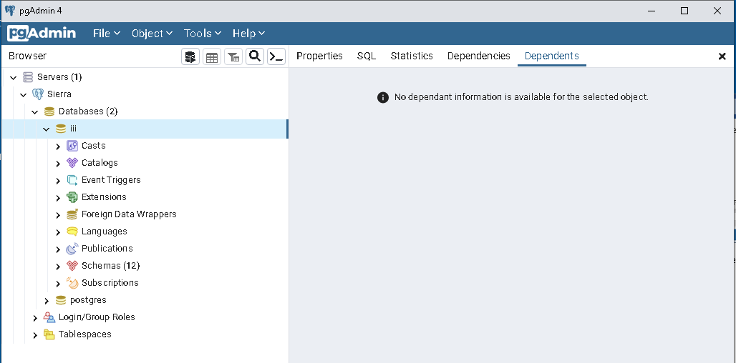
Figure 1 Navigation pane open to iii
Ignore everything except Servers / Sierra / Databases(2) / iii / Schemas(12)

- Double-click the name or click the expand icon next to Schemas (12)
Figure 2 Navigation pane open at Schemas
Ignore everything except the last entry under Schemas(12) / sierra_view

- Double-click the name or click the expand icon next to sierra_view
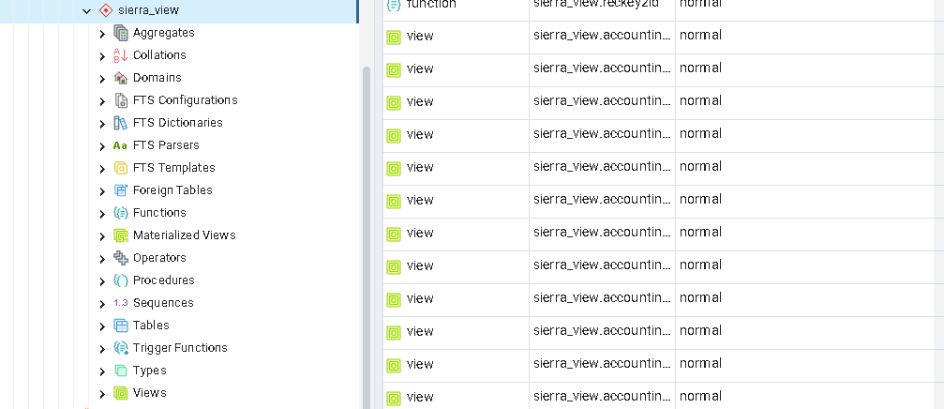
Figure 3 Navigation pane open at sierra_view

Ignore everything except the last one, sierra_view / Views

- Double click the name or click the expand icon next to Views (360)
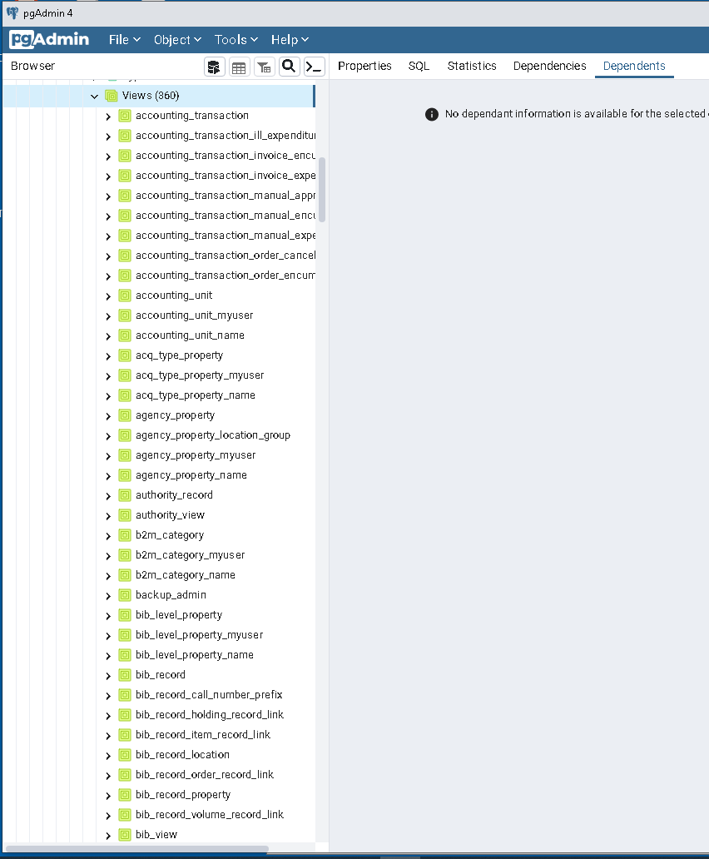
Figure 4 Navigation pane open at Views
There are 360 tables and views you can use to run SQL queries. The ones with the suffix “_view” are pre-defined combinations of fields from more than one table. We will focus on single table queries for now. The next time you open pgAdmin it may automatically open the navigation pane to this point.

List fields on a table
Double-click the name or click the expand icon next to bib_view, then click the expand icon next to Columns (18)
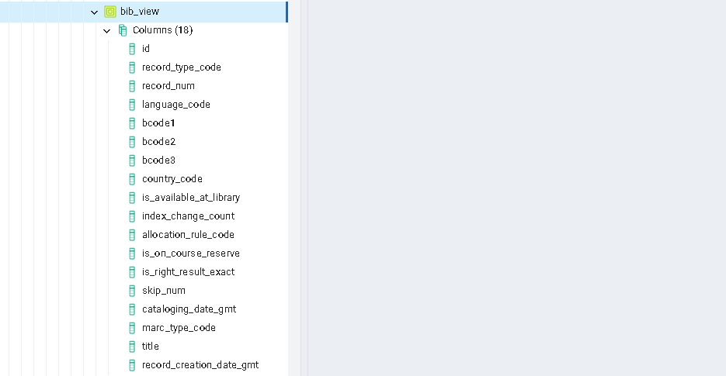
Figure 5 Navigation pane open to bib_view columns

With the bib_view columns expanded, we can see there are 18 “fields” or “columns” on the bib_view table.
Every table column has an associated type of allowed data. The types of data include integer, big integer, character, date or timestamp, numeric.

View / Edit Data
We will use the “View / Edit” function to explore the data. The name of this selection is a misnomer since you cannot edit the data. Ignore menu options that indicate otherwise.
- Right-click on bib_view to see a context menu.
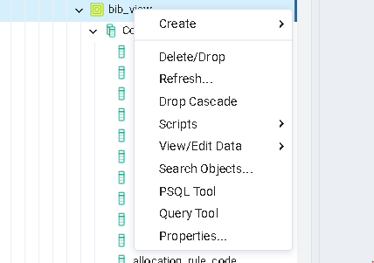
Figure 6 Table bib_view context menu
- From the context menu, select View / Edit Data
- Select Last 100 Rows
The right-hand side of the window has a Query pane above, and a pane at the bottom for Data output.
- Rearrange the size of the panes for a better view by clicking and dragging the divider between columns. 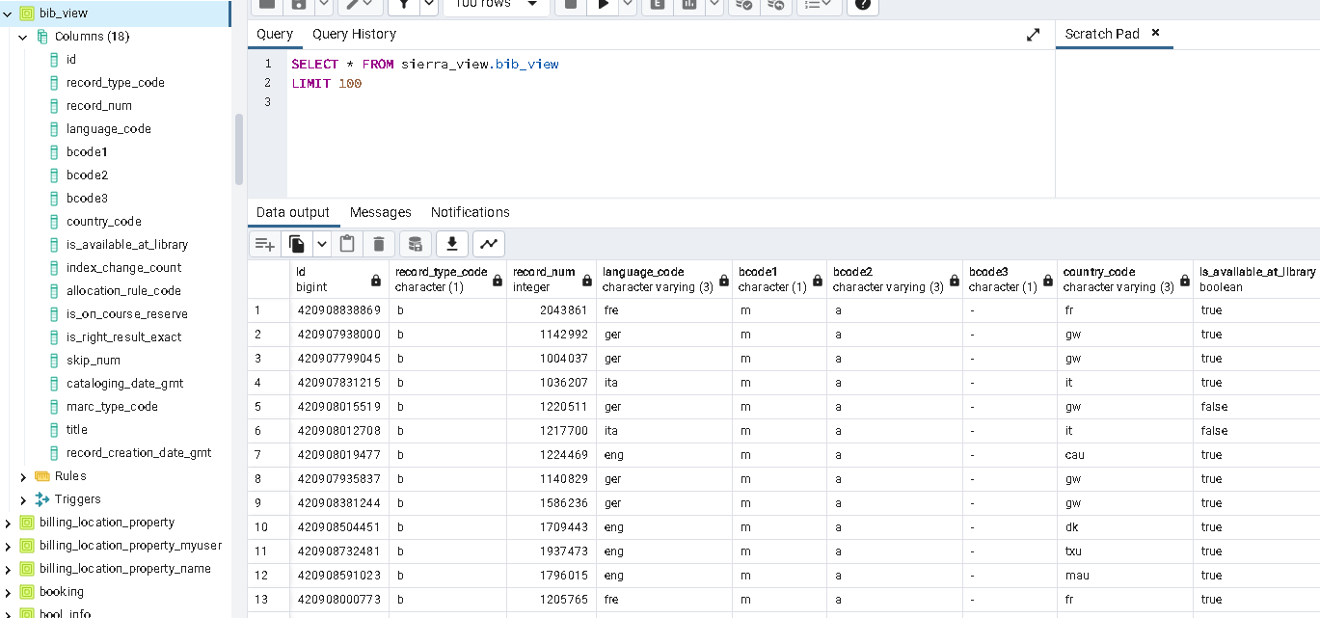
Figure 7 Output from View / Edit, last 100 rows of bib_view
- Notice the Query statement on the top pane.The asterisk character in the Query is a “wildcard” character meaning ALL fields.
- Click the “x” on the top, right corner of the query to close it

The Query Tool
Next, we will try out the option named “Query Tool” instead of “View / Edit Data”
- Right-click bib_view in the navigation pane again
- This time select Query Tool
- Copy / paste or type the following text into the Query pane:

SELECT
record_num,
language_code,
title,
cataloging_date_gmt
FROM
sierra_view.bib_view
limit 100

This SQL query will pull the first 100 records, similar to the View/Edit Data function.
Most SQL developers find that breaking up statements over multiple lines makes them easier to read and debug. You do not need to capitalize the words SELECT, FROM, WHERE, ORDER BY. However, it helps readability.
- Execute the query.
You can press F5 to execute the query or click the run icon 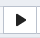 above the query pane.
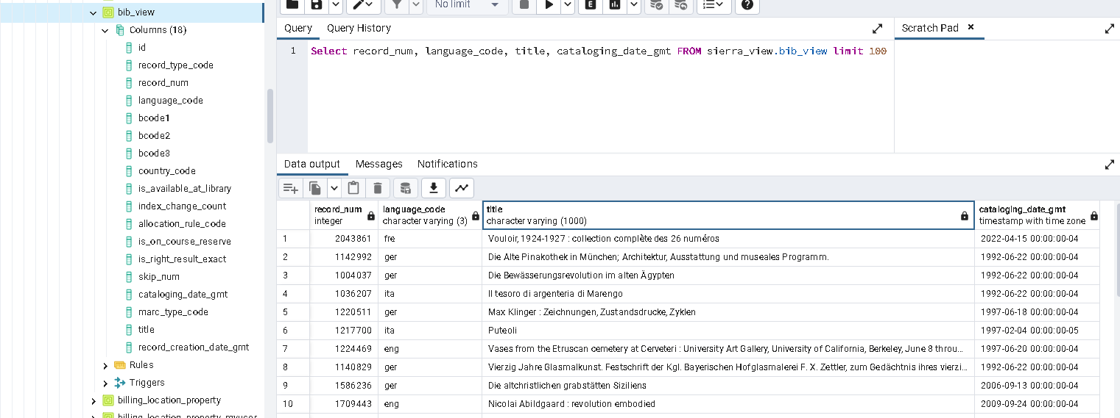
Figure 8 Output from Query Tool query of bib_view
You may want to resize the width of the fields in the Data output tab.

Query scripts and output
Those were two commonly used functions/ways to explore Sierra data. Now let’s take a look at how to save and retrieve your work.

Save a query
Save a SQL query statement by clicking the diskette icon (located above the Query workspace, it says “Save File” when you hover over it). Navigate to a directory and save the file. The file extension should be .sql

Open a saved query
You should be able to retrieve any of your previously saved SQL queries by clicking the folder icon above the Query pane (it says “Open File” when you hover over it).

Save / copy output
You can click the top left corner of the Data output tab to select all the output cells. Click the selector/down arrow next to the copy icon to choose whether to copy with headers.
Then type CTRL/c to copy. Open an Excel spreadsheet and paste (CTRL/v) the text.

Download output
You can download the output as a .csv file by clicking the download icon on the Data output tab (it says “Save results to file” when you hover over it) and then import the .csv file into Excel.

Copy query statement from MS Word to pgAdmin
[TIP] You can copy query statements from this Word document and paste the text into pgAdmin. However, beware of the smart quotes characters in Word; In pgAdmin, smart quotes cause syntax errors. You must change the smart quotes to single quote characters.

Basic SQL functions
Here are some useful terms related to the syntax of SQL:
- Function – one or a series of statements that perform a specific task; functions typically act upon a field named in parenthesis after the function name.
An example of a function is left(title, 40). The function name is “left.” Its task is to act on the title field, returning the specified number of characters. In this example, 40 characters.
- Clause – these add conditions to the function; they can be required or optional,
such as ORDER BY
- Operator – reserved word(s) or character(s) that define a condition in WHERE functions such as greater than “>” or equal to “=”
- Alias – this is exactly what you may think, an alternate way of referring to something. For example, the statement “cataloging_date_gmt as cat_date” establishes “cat_date” as an alternative to using the longer form.

Now let’s try a new query:
- Edit the original SQL query statement to look like the following revision.
- Take care to include punctuation and make sure the quotes are single quotes
(not smart quotes).

SELECT
id,
record_num,
language_code AS lang,
left(title,40),
cataloging_date_gmt AS cat_date
FROM
sierra_view.bib_view b
WHERE
language_code!='eng' and
title like 'A%' and
cataloging_date_gmt > '01-01-2022 00:00'
ORDER BY title
limit 20

- Execute the query (press F5) after making the revisions.

The statements introduced in the revised query are described below.

id
Nearly every table has a system-generated field named id or record_id of type “big int” - something like 420908827361. This id is the primary key of the record.

record_num
The record number does not include the last digit, nor does it include the prefix (such as “.b”, for bib numbers). The last digit, or “check digit” is a value the system calculates based on the other digits.

AS alias
language_code AS lang
The syntax “AS alias” is a way to change the field name displayed in the results to an alias

left(string,number)
left(title,40)
“left()” is a function that returns only the first number of characters of the field in parenthesis, starting from the left; the number of characters is the number in parenthesis.

table alias
FROM sierra_view.bib_view b
This statement establishes a very short alias for the table! We only need the alias, “b” if we refer to that table again.

The statements in the WHERE clause act as filters.

like %
title like ‘A%’
The “like” operator is used for approximate matches. In this example, it means the title begins with capital A and the % is a wildcard meaning match any others that follow.

Greater than operator
cataloging_date_gmt > ‘01-01-2022 00:00’
The operator “>” means greater than. The operator “<” means less than.

not equal
language_code!=’eng’
The operator “!=” means not equal. Use a single “=” to match equal.

ORDER BY title
“ORDER BY” means sort. By default, sorting is from lowest value to highest. Alternatively, you could say “ORDER BY title asc”. To sort in descending order, you would say “ORDER BY title desc.” If you use an “ORDER BY” clause it should always be the last clause in the SELECT statement.
It is possible to sort data by a column that is not retrieved in the SELECT statement. You can sort by multiple columns by specifying the column names separated by commas.

LIMIT
The LIMIT command allows you to control the number of rows a query will return.

Limits are important when you are developing queries. Include a limit number using a WHERE clause or you could inadvertently return thousands or even millions of rows of data!

A variant of your query may look something like the following. The concat function on line 3 in this example outputs a format of the bib that is searchable in Sierra.
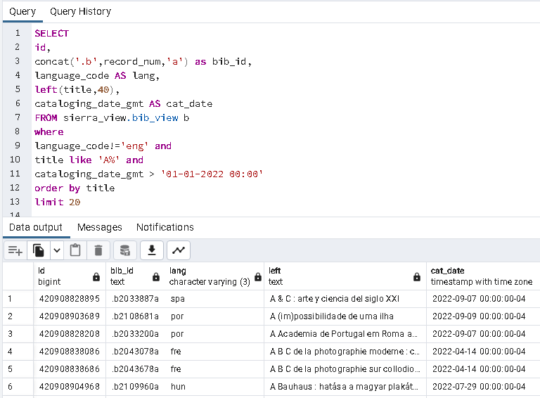
Figure 9 Output of a bib_view query with functions
You may need to adjust the column widths in the Data output.

concat() function
Concatenate is a function that combines two or more strings together. You could concatenate the appropriate prefix, the record number, and the wildcard check digit character “a” using the SQL concat function. Alternatively, you may use the SQL operator ”||“ to combine strings. Both techniques retrieve a value that looks like a complete record number such as .b1000202a. Here is the syntax you would use:

concat(‘.b’,record_num,’a’) as bib_id,

or

‘.b’ || record_num || ‘a’ as bib_id,

Alias
Notice an alias for the title was not provided in the example statement. The statement just says “left(title,40)” and the output shows the field name is “left.” It could have written “left(title,40) AS short_title” as an alias. The alias name of fields will appear in the output column heading.

Comments in SQL
You can include comment lines in your query statement. A comment is notation that is not part of the code. Prefix the comment line with two hyphens.
--filename: varfield.sql
--author : James Hendershaw
SELECT * from sierra_view.varfield_view
WHERE record_num = 2043861

Counting results
You can include a basic counter in your query statement.
SELECT count(*) from sierra_view.bib_view
WHERE lang= hun

id2reckey() function
The id2reckey() function is a handy tool for converting those long id numbers into the relevant, more familiar record number. This works for bib, item, patron, order, etc. Here is an example:

SELECT
id,record_id,id2reckey(record_id) as “bibid”
FROM
sierra_view.bib_record
WHERE
cataloging_date_gmt > ‘2022-10-13’

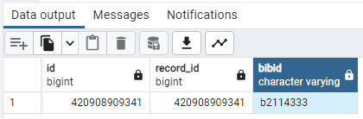
Figure 10 id2reckey() output Example 1
- The value returned from the id2reckey() function has a letter prefix.
- The check digit is not included.

Another example of id2reckey()

SELECT
id2reckey(v.record_id) as “bib_id”,
marc_tag, field_content
FROM
sierra_view.varfield_view v
WHERE
record_id=’420908909341’
order by marc_tag

The query results are shown on the next page.
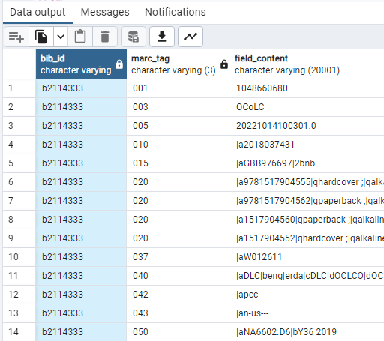
Figure 11 id2reckey() output Example 2

Handling errors
It’s certain that your query will have some kind of error as you develop your queries. Let’s edit the sample script to force it to produce an error.
- Edit the query. Change the statement that reads ‘order by title’ to ‘SORT BY title’
- Press F5 to execute the revised query
The program will not recognize the command. You should see an error in the message tab:
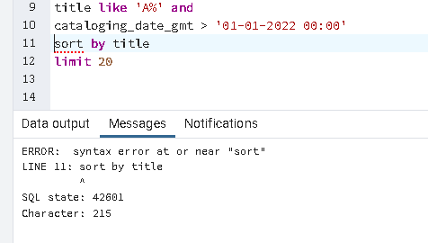
Figure 12 Messages tab showing an error
SQL will let you know what parts of a statement aren’t working. You can use the Error messages it provides to troubleshoot.
- Let’s go back to ‘ORDER BY title’
- Fix any other typos that may be present
- Press F5 to execute the query
[TIP] Additional tips for handling errors are provided in the Appendix of this document.

Close completed queries
It is important to close completed pgAdmin queries. This means you should close any query panes you have active once you finish the query and you are ready to move on to something else.
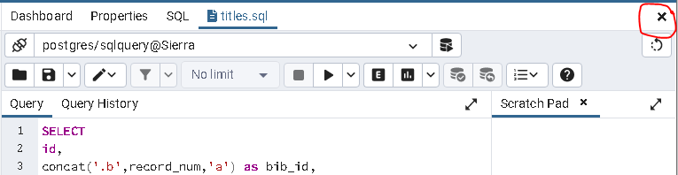
Figure 13 Query pane with Close icon highlighted
Click the “x” icon to close active query panes.

Simultaneous Query windows warning

pgAdmin allows only a few simultaneous SQL query connections Each SQL query you open in the query tool uses a connection.
If you exceed the number of allowed connections, you will see an error message and you won’t be able to run any queries.

If this happens, close pgAdmin and relaunch the program; it should allow you to continue.

The limit command
Earlier the Limit command was summarized. This subject is worth repeating. The Limit command allows you to control the number of rows a query will return.
Limits are important when you are developing queries. Include a limit number using a WHERE clause or you could inadvertently return thousands or even millions of rows of data!

Examples of limiting statements using ‘limit’, ‘in’, ‘between’, or ‘NULL’ that will help to contain the query results:
limit 500
where location_code = ’off’
where checkout_total > 1000
where expiration_date_gmt > ’2026-12-31 00:00’ and ptype_code = 10
where expenditure between 1000 and 1500
where location_code in (’off’,’s’,’ref’)
where location_code = ’off’ or ’www’
where location_code is NULL
You do not need to enclose numeric values in quotes.

Working with Date and Time fields
There are functions you can use to manipulate columns that represent date and time. Here are three functions you will find useful.

Date_part(), extract(), and to_date().
The examples below assume we are given the date time value 2022-09-07 08:30:00-04
Query Statement Returns
date_part(‘year’,cataloging_date_gmt) 2022
extract(year from cataloging_date_gmt) 2022
extract(month from cataloging_date_gmt) 9

Workshop 1
Now that you’ve had a chance to see different types of tables and what data they store. it’s time for you to write some SQL queries using the Query Tool. The following exercises will both use the functions you’ll recognize from above and familiarize you with some of the most used/main tables and entities used.
[TIP] Note: if you get stuck, check the Trouble shooting common SQL errors.

SQL query exercises using a single table
- Close any query windows you may left open from the above exploration of tables
- Select Tools > Query Tool from the menu bar
- Just a reminder:
  - You can expand a table in the views to reveal the column names
  - Save each of your queries for later.
  - Be sure to close the query when you’re finished before going on the next one.
  - It would be helpful to navigate to the view in pgAdmin to see what fields are in each view and ensure you’re using the right name of them in your queries

Exercise 1: bib_view

The bib_view table has quite a few fields.  You can see the list of fields or ‘columns’ by expanding the table name bib_view and the Columns in the navigation pane. | 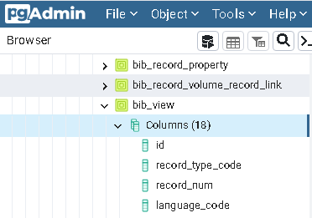

Write a simple query. The SELECT clause should specify the fields listed below. The FROM clause should specify the Table named sierra_view.bib_view. The WHERE clause specifies we want records where the catalog date is after October 11, 2022 and the language code is equal to ‘spa’ (Spanish). The WHERE clause you should use is shown below.
[Tip]: Figure 9 is a similar query.
Fields: id, record_num, cataloging_date_gmt as cat_date, left(title,40) as title
Table: sierra_view.bib_view
Where: cataloging_date_gmt > ‘2022-10-01’ and language_code = ’spa’
Limit: 10
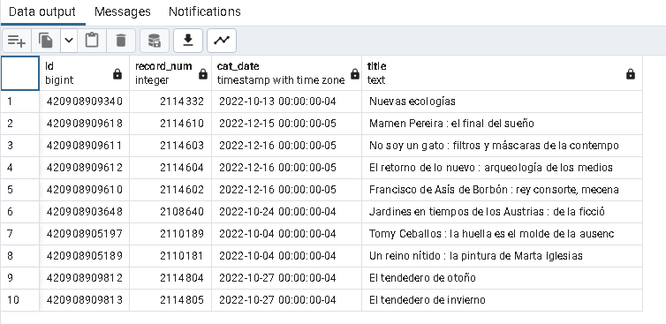
Figure 14 Exercise 1 query output
Your data output should appear like this screenshot. (You may need to widen the title column.)

Exercise 2: varfield_view

The varfield_view table contains all the MARC tags from bib records and variable fields from other records like patrons.
The column named “field_content” has the variable field text. The field_content includes subfield delimiters.
Save and Close your Exercise 1 query.
Write a new query to retrieve the variable fields for the given record number. As before, you will need to put the following specifications into the appropriate SQL clauses: SELECT, FROM, WHERE. This exercise also sorts the results. You add an ORDER BY clause at the end.
Fields: record_id, record_num, marc_tag, field_content
Table: sierra_view.varfield_view
Where: record_num = 2043861
Order by: marc_tag
The query specifies a single record number, so you do not need to include a limit statement.

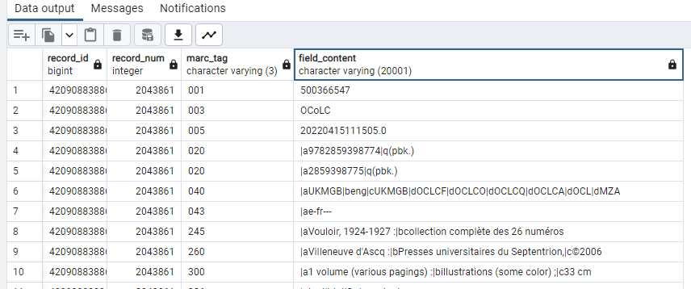
Figure 15 Exercise 2 query output
Your data output should appear like this screenshot
The delimiter markers (|a, |b, |c, etc) that appear in the field_content look very strange but that is not an error.

Exercise 3: subfield_view

The subfield_view table removes the delimiter markers from varfield_view.field_content, itemizing every subfield as a separate line.
Write a query to retrieve some of the MARC tags and subfields as specified below.
Fields: record_num, marc_tag, tag, content
Table: sierra_view.subfield_view
Where: record_num = 2043861 and marc_tag between ‘245’ and ‘299’
Order by: marc_tag, tag, display_order
Notes:
- The subfield_view table has a field named “display order” which can be used to sort subfields within the tag.
- The field named “tag” is actually the subfield.
- The marc_tag field is defined as a character field, so you need to put quotes around in the WHERE clause even though the tag looks like a number.

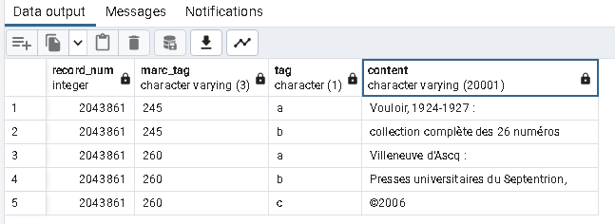
Figure 16 Exercise 3 query output
Your data output should appear like this screenshot

Exercise 4: phrase_entry

The phrase_entry table stores all the indexed values.
Entries in this table having record_type_code ‘b’ are bib index values; the index_tag indicates the type of index (e.g., a=author, i=isbn, c=call number, t=title, etc.)
Write a query to display the index entries for the bib with the system-generated record_id provided below.
Fields: record_id, index_tag, varfield_type_code, index_entry
Table: sierra_view.phrase_entry
Where: record_id = 420908838869
Order by: index_tag, varfield_type_code
Limit: 20
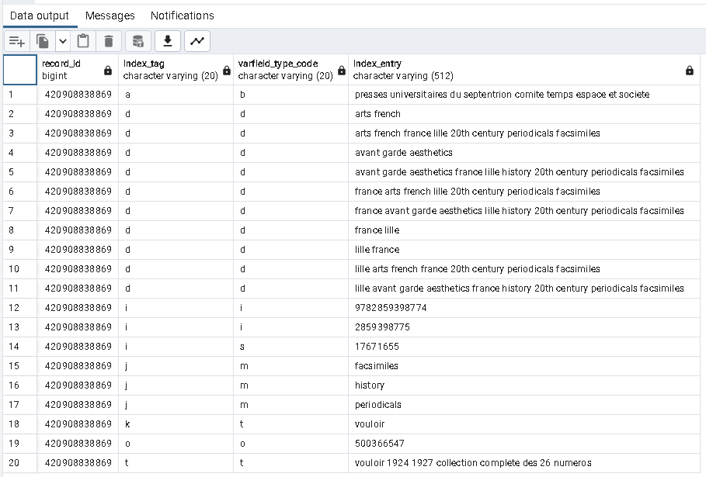
Figure 17 Exercise 4 query output
Your data output should appear like this screenshot

Convert id field to a record number id2reckey()

The id2reckey() function is a handy tool for converting those long id numbers into the relevant, more familiar record number. This works for bib, item, patron, order, etc. Here is an example:

SELECT
record_id, id2reckey(record_id) as bibid, language_code
FROM
sierra_view.bib_record
WHERE
cataloging_date_gmt > '2022-10-13' and
language_code not in ('eng', 'fre', 'ger', '')
limit 10

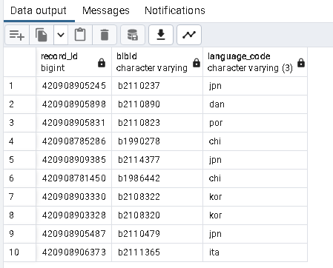
Figure 18 Example of id2reckey() function
Notes:
- The value the id2reckey() function returns is a character with a letter prefix.
- The “check digit” is not included at the end of the bibid returned by the id2reckey() function.
- The script above shows an example of using the in() or not in() function. That function will match a comma separated list, or exclude a comma separated list.
- The empty element at the end of the list for language_codes means exclude records where there is no language_code

Another example of id2reckey()

SELECT
id2reckey(v.record_id) as “bib_id”,
marc_tag, field_content
FROM
sierra_view.varfield_view v
WHERE
record_id='420908909341'
order by marc_tag

Figure 19 id2reckey() output example2

Exercise 5: bib_record_location

Write a simple query to retrieve the locations for a specific bib using the system’s bib_record_id
given in the exercise below.
Fields: bib_record_id, id2reckey(bib_record_id),location_code
Table: sierra_view.bib_record_location
Where: bib_record_id=420908719549

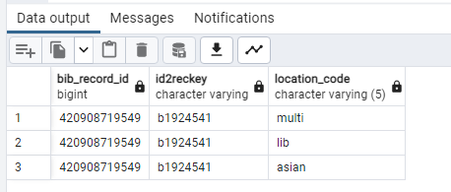
Figure 20 Exercise 5 query output
Your data output should appear like this screenshot

Exercise 6: item_record_property

There are a lot of fields on the table item_view, but it doesn’t include the item call number. You’ll find the item call number on item_record_property records. In fact, the table has the value entered and a ‘normalized’ version of the call number. The normalized version strips out delimiters and converts everything to lower case.
Use the following specifications to write a query against the item_record_property table.
Fields: id2reckey(item_record_id) as item_no, call_number, call_number_norm, barcode
Table: sierra_view.item_record_property
Where: call_number_norm like ‘nd20%’
Limit: 10
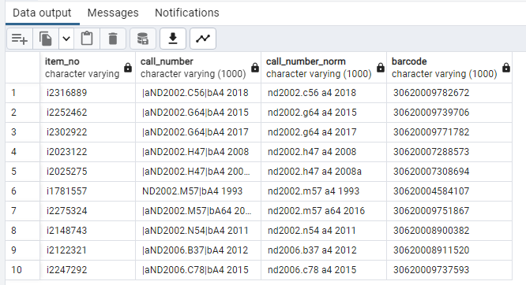
Figure 21 Exercise 6 query output
Your data output should appear like this screenshot

Exercise 7: patron_view

Let’s look at some non-MARC data. Write a query to list patrons and their total checkout count.
To make this a little more challenging, the conditions for the where clause given below need to be put in the proper SQL syntax. That is, you need to use the correct field/column name, the appropriate operator symbol, and enclose character field/columns in single quotes.
Fields: record_num as patronID, barcode, checkout_total
Table: patron_view
Where: the barcode starts with 2062000 and
the ptype code is 6 and
the checkout total is greater than 49
Limit: 10
Hint: Postgres SQL does not use ‘starts with…’ Instead use the ‘%’ wildcard character.
The condition like ‘2062000%’ means the value starts with 2062000
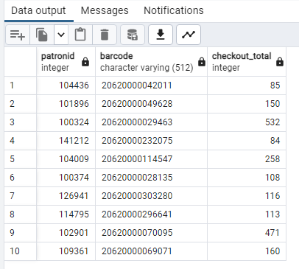
Figure 22 Exercise 7 query output
Your data output should appear like this screenshot

Exercise 8: user_defined_pcode1_myuser

Write a simple query to display the institutions displayed in the patron record.
The patron institution code is stored on the patron_view table. The descriptions for Watson’s institution codes are in the lookup table named ‘user_defined_pcode1_myuser’. This query will get the description from the user_defined_pcode1_myuser table. Other examples of lookup tables are in the Appendix.
There is a column on this table named ‘display_order’. You don’t have to select that field, but sort the results by that field.
Fields: code, name as institution
Table: sierra_view.user_defined_pcode1_myuser
Order by: display_order
Limit: 15
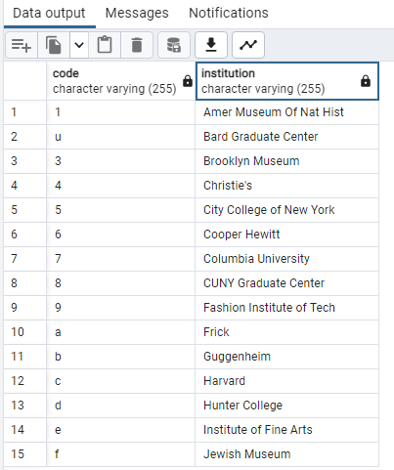
Figure 23 Exercise 8 query output
Your data output should appear like this screenshot

Exercise 9: patron_record_address

It’s a constant battle to enforce data entry rules. Since patrons can self-register, they often input the wrong thing in the registration form. A common error is they input “NY” for the city and leave the state blank.
Write a query to pull the following fields from the patron address table. Use the functions and column aliases shown.
Fields: id2reckey(patron_record_id) as patronID, addr1, city, region AS state, postal_code as zip, country
Table: sierra_view.patron_record_address
Where: city = 'NY'
Limit: 10
Results will contain addresses where the data has a blank state and ‘NY’ as the city.

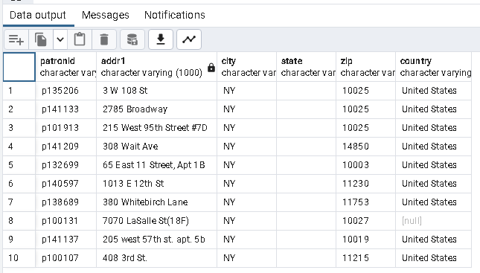
Figure 24 Exercise 9 query output
Your data output should appear like this screenshot
Go edit those records (just kidding!).

Exercise 10: hold

The hold table stores hold requests. It includes the ids of the item and patron. The item barcode is not included in this table, but this table provides the basic information about the old.
Write a query to select the following fields with the alias names shown. You should use a recent date rather than the one shown below.
Fields: id as hold_id, id2reckey(patron_record_id) AS patron, id2reckey(record_id) AS item,
placed_gmt
Table: sierra_view.hold
Where: placed_gmt > ‘2022-12-22 00:00’
Order by: hold_id
Limit: 10

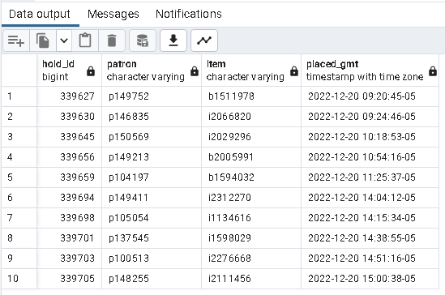
Figure 25 Exercise 10 query output
Your data output should appear like this screenshot
In the Part 2 of the course you will learn how enhance this hold script to retrieve the associated barcode for the item from another table.

Exercise 11: challenge

Up to now you were given the specific fields, table name, and where clause necessary to complete an exercise. Hopefully in doing the exercise you didn’t run into too many errors – and if you did you were able to fix them.
For this last exercise, please see the screenshot of a query’s output below.
Your challenge is to find the table in the database that contains the column names shown in the screenshot.
After you determine the table you need, write an SQL query to replicate the following results.
Select only the left-most 50 characters of the fields named “best_title” and “best_author”.
Limit results to 15 rows.
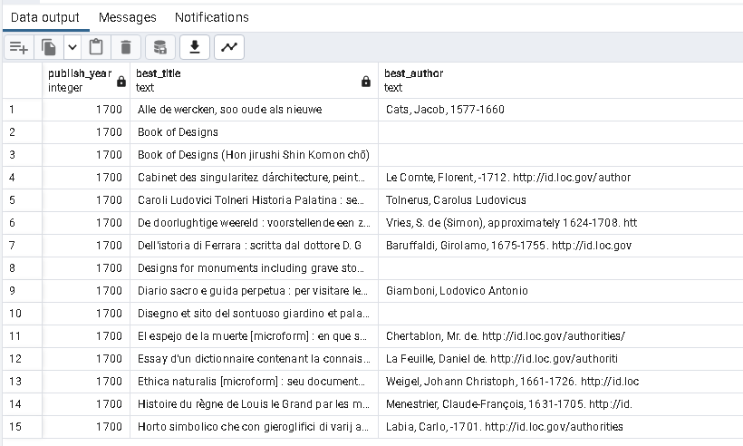
Figure 26 Exercise 11 challenge output

What’s Next

If you feel comfortable with the course material up to this point and did not have much trouble with Exercises 1-10, you are ready for Part 2 of the course.

You have completed the basic introductory skills using pgAdmin to explore Sierra data. There is still a great deal more to learn. The Appendix which follows contains information for future reference.

Use the Appendix as a resource
Intermediate / Advanced Functions
A few examples of somewhat complicated functions are described in the Appendix section of this document, under the heading “Intermediate / Advanced Functions.”
Categories of Tables
The Appendix provides summaries of general categories of the tables in Sierra with examples and suggestions how to browse these tables. You should find this list useful when you need to choose which table to query.
Troubleshooting Common SQL Errors
Refer to this section for help when you are developing your SQL queries. You will almost certainly run into some errors along the way, so hopefully the tips provided here will help you correct them.
Solutions to Exercise Problems
The solutions to Exercises 1 – 10 are provided in this section of the Appendix.

Part Two of Sierra & SQL
Part Two of this course will build upon what you have learned so far. We mentioned that no single table fully describes a concept like a patron or book. Instead, we will need to retrieve information from two or more tables to get a complete description of something. Part Two focuses specifically on using SQL to retrieve data from multiple related tables.

Appendix

Intermediate / Advanced functions
Here are a few more functions you can use in your SQL queries for future reference.

Regular expressions in SQL
If you need to use a regular expression (or a pattern of characters that is recognizably standardized like a social security number or a 7-digit phone number), this is supported in SQL. For example, this looks for a 7-digit phone number:
-- 7-digit phone pattern
WHERE patron_record_phone.phone_number ~ '^[0-9]{3}\-[0-9]{4}$'

Convert a field type using cast()
Sierra stores currency as regular numbers. You can use the cast() function to display the output of this type as money. Here is an example: cast((amt.start_charge) as money) as paid

SELECT
voucher_num,
paid_amount,
cast((paid_amount) as money) as paid
FROM
sierra_view.order_record_paid
WHERE
voucher_num=32323

Find the aggregate value max()
You can use the max() function to find the maximum value of something. For example, this finds the highest patron ID assigned to date:

SELECT
max(record_num)
FROM
sierra_view.patron_view

Group by
You can use the ‘GROUP BY’ clause to get totals or subtotals over a group of records. For example, this query groups bib records by their material type code and counts how many there are for each group.

SELECT
material_code,count(*)
FROM
sierra_view.bib_record_property
WHERE
material_code in ('3','s','a')
GROUP BY material_code

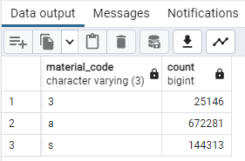
Figure 27 Output from a GROUP BY clause

Notes
- Every column listed in the group by clause must be included in the select clause.
- GROUP BY clause must come after the WHERE clause and before any ORDER BY clause.

Group by rollup
The output of the previous example shows the number of Text and Auction bib records. It begs the question, “What is the total?” The rollup function provides the total of the group.

SELECT
material_code,count(*)
FROM
sierra_view.bib_record_property
WHERE
material_code in ('s','a')
Group by rollup(material_code)

The new output will contain the total of the groups:

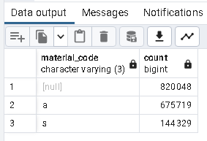
Figure 28 Group output with rollup total

Suggestion: Rather than overcomplicating the SQL query, just retrieve ungrouped data. Then export the data and bring it into Excel or Google Refine where it is easier to group data using a pivot table.

filter()
Another function that may be applied to aggregate values is the filter() function. As you can see in the example below, the WHERE clause is performed on a field by field basis:

SELECT
location_code, COUNT(id) AS total_items,
COUNT(id) FILTER(WHERE item_status_code = '-') AS total_available,
COUNT(id) FILTER(WHERE item_status_code = 'm') AS total_missing
FROM
sierra_view.item_record
GROUP BY 1
ORDER BY 1;

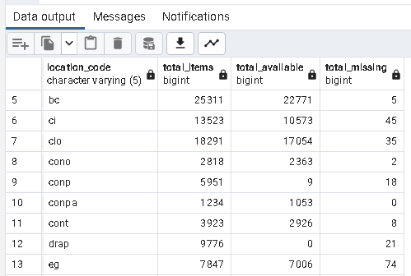
Figure 29 Output from a query with filter()

The HAVING clause
When you create a group, you may apply a filter on the group by using a ‘HAVING’ clause.
For example, if you add the following line at the end of the above script, the output will only is material codes a and s:

HAVING count(*) > 100000

Aggregate functions
SQL supports several functions when you have a group, including
- SUM()
- AVG()
- Min()
- MAX()
- COUNT()

CASE statements / conditional statements
You may want to control the output based on a condition. For example, given the SQL query that counts bib records by material type code, you might output a description instead of a code. Take this script that outputs a single character code:

SELECT
material_code,count(*)
FROM
sierra_view.bib_record_property
WHERE
material_code in ('s','a')
GROUP BY material_code

We can convert the default material_code using a conditional statement. We give the result of the CASE statement the alias mat_type:
SELECT
CASE
WHEN material_code = 'a'
THEN 'Text'
WHEN material_code ='s'
THEN 'Auctions'
END mat_type,
count(*) as qty
FROM
sierra_view.bib_record_property
WHERE
material_code in (‘s’,'a')
GROUP BY material_code
HAVING count(*) > 100000

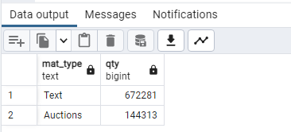
Figure 30 Output after using a CASE condition
In the above queries you could use the position of the field in the SELECT statement instead of the field name in the GROUP BY clause. That is, you could say ‘GROUP BY 1’

array() and array_to_string()
An array is basically a list. This function may be useful when you have a repeatable field in a record. As an example, consider this query that retrieves the repeatable field ‘location’ from a bib record.
Notice the array element is based on a SELECT query within the first SELECT query. That query retrieves all location codes on a bib and separates each location by a comma. It doesn’t bother to include the location code ‘multi’ since that’s included when there is more than one location
The results of the array of location names obtained by the second ‘SELECT’ clause passed to the other function, array_to_string. That function simply does just that – it makes a single character string out of the list of locations and gives the string the alias name ‘loc_codes.

SELECT
ID2RECKEY(id),
array_to_string(
array(SELECT location_code
from
sierra_view.bib_record_location as bibloc
WHERE
sierra_view.bib_view.id = bibloc.bib_record_id
-- we don't need to see the word multi
and location_code != 'multi'
order by 1),', ')
as loc_codes
FROM
sierra_view.bib_view
LIMIT 25

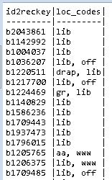
Figure 31 Output using a string array for bib loc(s)
The previous example uses a second SELECT statement, known as a sub-query. It also joined two tables, bib_view and bib_record_location. An explanation of those features will be provided in Part Two of the SQL course.

More functions
There are many more postGres SQL functions available besides the ones described in this document. Here is a list of examples:
exists not exists lag() lead() over() rank()
partition() split_part() replace() substring() lower() upper()
length() string_agg() age() now() to_number() reverse()
distinct join union left join right join

Types of data tables

List of values tables
Some tables simply provide a list of values for the system. Usually, they have an id field and a description field. Here are some examples of tables that have that structure:
acq_type_property_name | foreign_currency | item_status_property_name
location_name | ptype_property_name | record_type_name
scat_category_name | user_defined_pcode1_myuser | user_defined_pcode2_myuser
Table 2 List of some value tables

Explore list of values tables with View / Edit
Take a few minutes to examine the values in some of the list of value tables. Follow these steps:
- expand open sierra_view > Views
- right-click the table name you want to explore
- select View / Edit
- you can select All Rows since these tables don’t have many records
- peruse the data output, close the query

Descriptive data tables
Several tables store what you would consider data. It may be descriptive data (e.g., bib, item, order, vendor, etc.) or transaction data (e.g, check outs, holds, orders).
Here are a few tables that provide descriptive data:
bib_record | bib_record_location | bib_view
varfield_view | bib_record_property | item_record
item_view | order_record | order_view
patron_record | patron_view | patron_record_address
phrase_entry | resource_record | resource_view
Table 3 Some descriptive data tables

Explore descriptive data tables with View / Edit
Take a few minutes to examine the values in some of the descriptive tables. Use the following steps
- expand open sierra_view > Views
- right-click the table name you want to explore
- select View / Edit
- select Last 100 rows because these tables have many thousands of records
- peruse the Data output, close the query

Transaction data tables
A transaction table stores a record of activity such as hold placed on an item. Here are the names of a few transaction tables.
checkout | hold | invoice_record
invoice_view | order_record | record_metadata
Table 4 Some transaction data tables

Explore transaction data tables with View / Edit
Take a few minutes to examine the values in some of the transaction tables. Use the following steps
- expand open sierra_view > Views
- right-click the table name you want to explore
- select View / Edit
- select Last 100 rows because these tables have many thousands of records
- peruse the Data output, close the query

Other data tables
There are other tables which are primarily used to show the relationship between multiple tables. Tose so-called linking tables are discussed in Part Two of this course.

Trouble shooting common SQL errors
You will undoubtedly make mistakes as you type your SQL query. To show you some of the most common mistakes let’s start with the correct syntax of this query:
1 SELECT
2 record_num,
3 marc_tag,
4 field_content
5 FROM
6 sierra_view.varfield_view
7 limit 50
Below are some of the most common error messages you will see and the query that elicited them. You can compare them to the above if you’re not clear about how to correct your query.

Column does not exist
A field in the query does not exist. It may be spelled incorrectly, or the name is not valid. View the list of column names to find the problem.

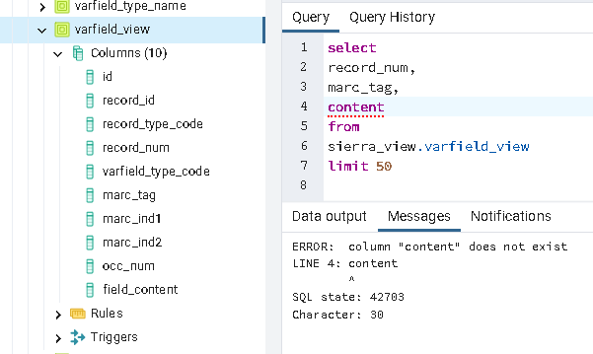
Figure 32 Error: column does not exist
In this example the field name ‘content’ is wrong – the correct field name is “field_content” so you need to edit line 4.

Syntax error
There are many sorts of syntax errors you might come across. Here is the error you will see if you have a comma following the last field in the SELECT clause (also known as a trailing comma):
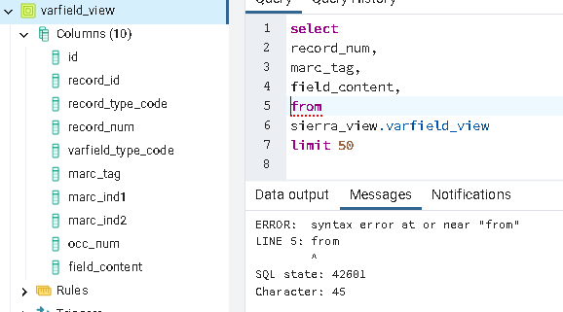
Figure 33 Error: trailing comma in SELECT

Below, we are missing the commas that should follow record_num and marc_tag
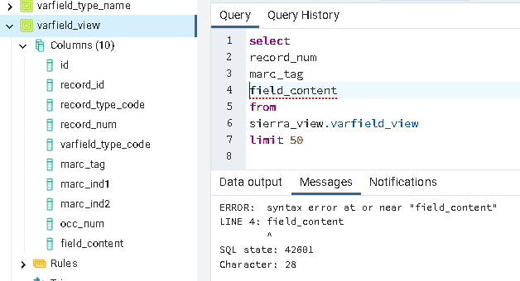
Figure 34 Error: missing commas between fields

Missing table prefix
In some SQL environments you cannot just give the table name in the FROM clause. In pgAdmin, you must prefix table names with “sierra_view.” So in the example below line 6 should say: sierra_view.varfield_view
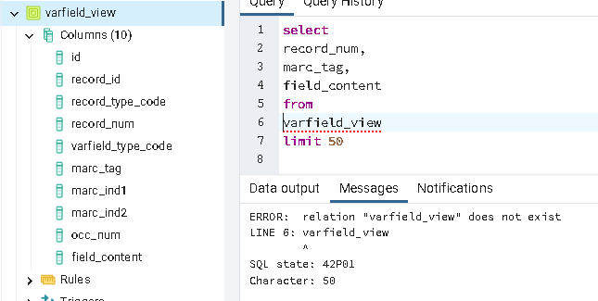
Figure 35 Error: missing table prefix sierra_view.

Missing parameters in a function
Sometimes you will use a function but forget the appropriate parameters that should go in the parenthesis. Here, we intended to ask for the first 40 characters of a title. We used the left() function. That function needs two parameters, the field name and length to return. Line 2 should say left(title,40):
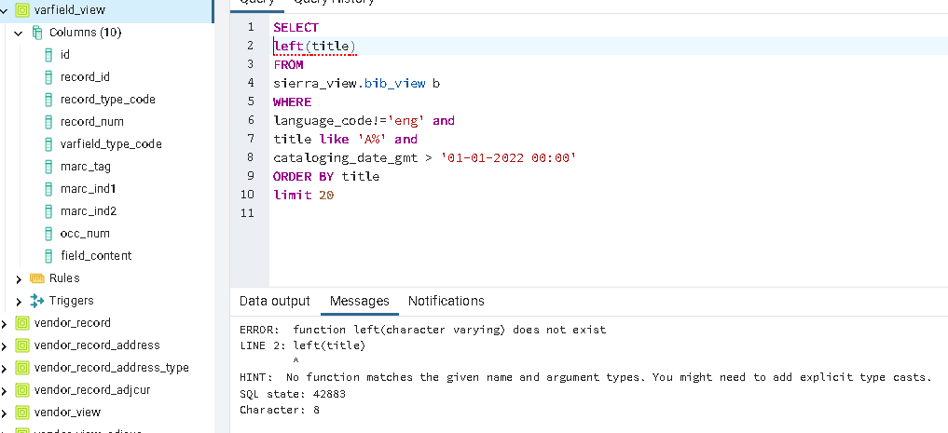
Figure 36 Error: function not recognized. Incomplete parameters

Incorrect or missing wildcard
When you are using wildcard characters as a filter, you may run into problems if you get the syntax wrong. Here, we meant to retrieve titles that begin with ‘A’ but forgot the wildcard for “like” and returned zero results. Line 7 should include the character wildcard symbol.
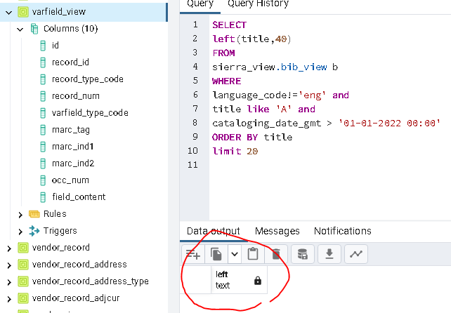
Figure 37 Error: incorrect or missing wildcard syntax
It should say:
title like ‘A%’ and

Solutions to Exercises
Exercise 1 Solution
-- SQL4LIB
-- 1. bib_view
SELECT
id, record_num, cataloging_date_gmt as cat_date,
left(title,50) as title
FROM
sierra_view.bib_view
WHERE
cataloging_date_gmt > '2022-10-01' and language_code = 'spa'
LIMIT 10

Exercise 2 Solution

-- SQL4LIB
-- 2. varfield_view
SELECT
record_id, record_num, marc_tag, field_content
FROM
sierra_view.varfield_view
WHERE
record_num = 2043861
ORDER BY marc_tag

Exercise 3 Solution

-- SQL4LIB
-- 3. subfield_view
SELECT
record_num, marc_tag, tag, content
FROM
sierra_view.subfield_view
WHERE
record_num = 2043861 and marc_tag between '245' and '299'
ORDER BY marc_tag, display_order

Exercise 4 Solution

-- SQL4LIB
-- 4. phrase_entry
SELECT
record_id, index_tag, varfield_type_code, index_entry
FROM
sierra_view.phrase_entry
WHERE
record_id = 420908838869
ORDER BY index_tag, varfield_type_code
LIMIT 20

Exercise 5 Solution

-- SQL4LIB
-- 5. bib_record_location
SELECT
bib_record_id, id2reckey(bib_record_id, location_code
FROM
sierra_view.bib_record_location
WHERE
bib_record_id = 420908719549

Exercise 6 Solution

-- SQL4LIB
-- 6. item_record_property
SELECT
id2reckey(item_record_id) as item_no, call_number,
call_number_norm, barcode
FROM
sierra_view.item_record_property
WHERE
call_number_norm like 'nd20%'
LIMIT 10

Exercise 7 Solution

-- SQL4LIB
-- 7. patron_view
SELECT
record_num as patronID, barcode, checkout_total
FROM
sierra_view.patron_view
WHERE
barcode LIKE '2062000%' and
ptype_code = 6 and
checkout_total > 49
LIMIT 10

Exercise 8 Solution

-- SQL4LIB
-- 8. user_defined_pcode1_myuser
SELECT
code, name as institution
FROM
sierra_view.user_defined_pcode1_myuser
ORDER BY
display_order
LIMIT 15

Exercise 9 Solution

-- SQL4LIB
-- 9. patron_record_address
SELECT
id2reckey(patron_record_id) as patronID,
addr1, city,
region as state,
postal_code as zip, country
FROM
sierra_view.patron_record_address
WHERE
city = 'NY'
limit 10

Exercise 10 Solution

-- SQL4LIB
-- 10. hold
SELECT
id as hold_id,
id2reckey(patron_record_id) as patron,
id2reckey(record_id) as item,
placed_gmt
FROM
sierra_view.hold
WHERE
--
-- change the placed_gmt date to a recent date
--
placed_gmt > '2022-12-20'
ORDER BY hold_id
limit 10

Exercise 11 Solution

-- SQL4LIB
-- 11. Bib_record_property
SELECT
publish_year,
left(best_title,50) as best_title,
left(best_author,50) as best_author
FROM
sierra_view.bib_record_property
WHERE
publish_year = 1700
ORDER BY publish_year, best_title
LIMIT 15

Cover generated by https://orly.nanmu.me/
For general information about PostgreSQL visit https://www.postgresql.org/
There are variants of SQL like MySQL, Oracle, SQL server. Minor differences in syntax exists between these. If you do any research outside the scope of this document, be sure to use the official documentation found at https://www.postgresql.org/docs/current/

