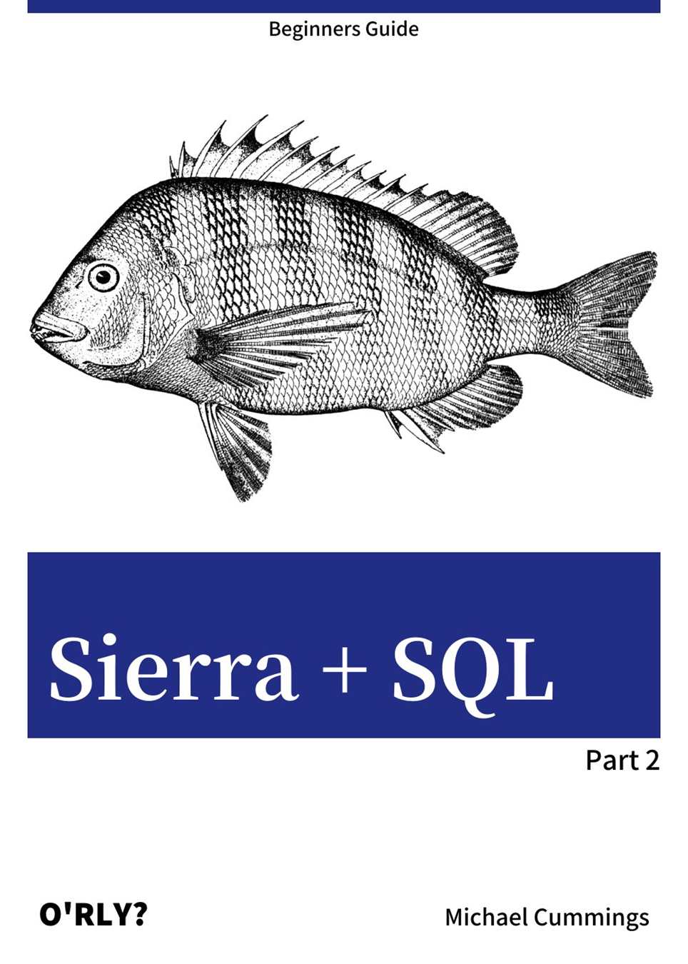
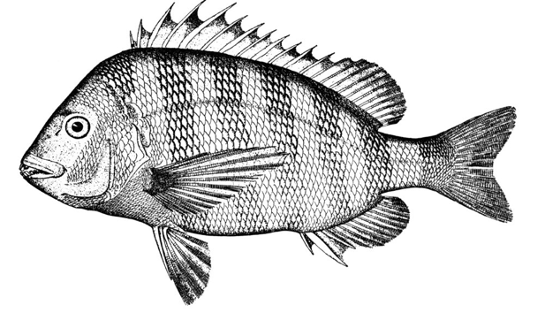
Edited by Carol Choi

Contents
Introduction 3
Query Development 3
Retrieving descriptive text for codes, an example 4
Sierra DNA database documentation 5
Joining tables 12
Rules for joining tables 16
Joining tables with a WHERE clause 16
Joining tables with the JOIN statement 20
Examples 21
Joining Data Tables 23
bib_view and varfield_view 24
bib_view, item_view, and bib_record_item_record_link 25
hold, patron_record_fullname, item_view, and bib_record_item_record_link 27
Tables often used in queries 28
Left Joins 29
left join syntax 33
Left join examples 35
Patrons and patron_addresses 35
Bibs and items 36
Further Study 37
Appendix 38
Some SQL Queries used at Watson Library 38
Address checker 38
Items checked out from book cage 40
All patrons 41

Introduction

This is Part 2 of a two-part course called, “Sierra + SQL.” This material focuses on using pgADMIN and Sierra documentation to develop queries that involve more than one table or, in SQL terms, multiple table JOINs. These complex queries are demonstrated through different examples.
Completion of Part 1 is prerequisite to the material in this document. The reader should:
- have installed pgAdmin
- have configured a connection to Sierra via pgAdmin
- be able to navigate the PgAdmin views
- know how to list the columns/fields in a table
- know the basic SQL syntax for SELECT, FROM, and WHERE clauses
It will be helpful if you can access pgAdmin and the online SierraDNA documentation while you are working your way through the course material.

Query Development

It is common practice in database design to store brief codes on data records instead of descriptive text. The descriptive text is typically stored in a separate table. This is a good starting point for learning about multi-table queries. Let’s look at a couple of examples involving code lookups in Sierra.

Retrieving descriptive text for codes, an example
A table that stores many fields with information about bibs is named sierra_view.bib_view. Recall from Part 1 of the course that you get a list of fields in a table by expanding Columns in PgAdmin as shown below, left.
Based on the field names on the bib_view table, several fields look like they store a short character abbreviation or number code: ‘language_code’, ‘bcode1’, bcode2’, and ‘country_code’ fields.
This screen shot from PgAdmin shows the fields on the bib_view table, an SQL query statement that selects the code fields, and the data output when the query ran.

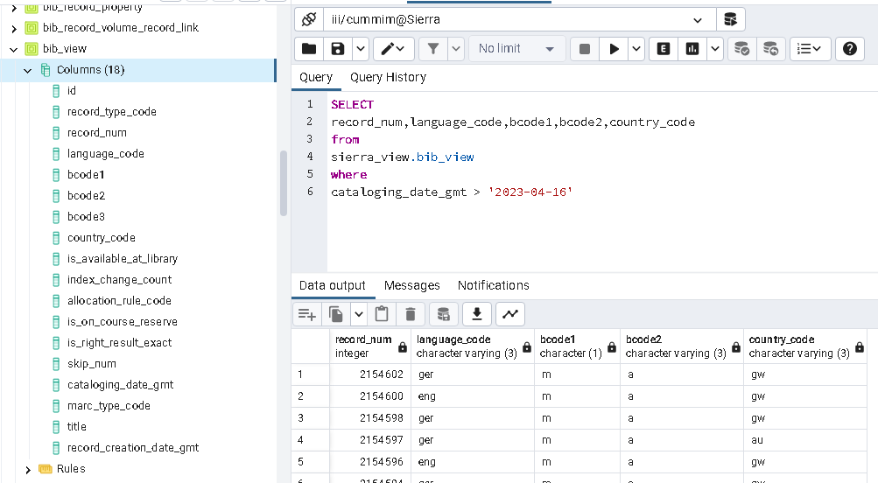

Looking at the data output, it should be obvious that the language_code ‘eng’ means English and ‘ger’ means German. The meaning of other codes (‘m’, ‘a’, ‘gw’, ‘au’) are not very obvious. Another problem is that the field names “bcode1” and “bcode2” are not meaningful.
We will learn how to find the descriptions of those codes using the database documentation.

Sierra DNA database documentation

Online documentation about Sierra tables, views, and relationships between tables is known as “Sierra DNA.” We will go through an exercise to research fields and table relationships using this documentation.
- Open a browser window to https://techdocs.iii.com
- Login with your library’s credentials
- Choose Sierra DNA on the left
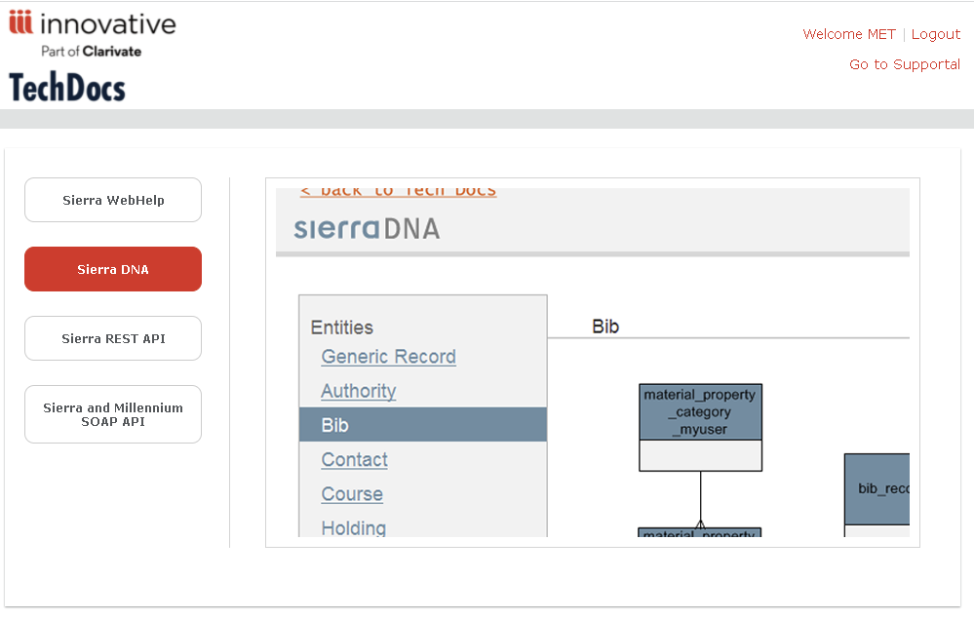
- select Entries
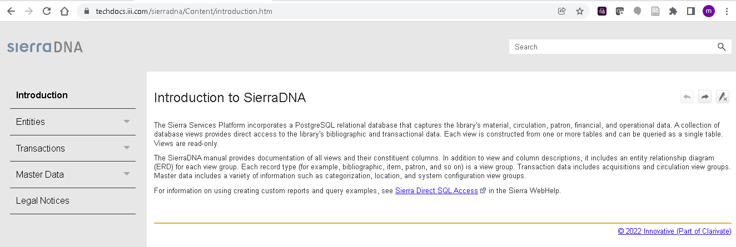

- select Bib. We are looking for information about codes on the bib_view table
- select Detailed View
- scroll down to find bib_view
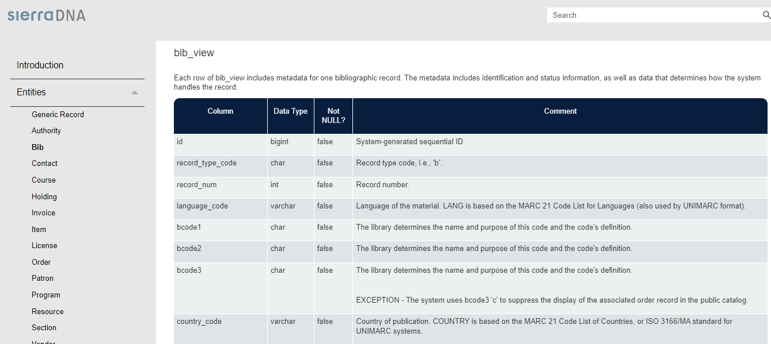
As far as the codes we are looking for are concerned, the detailed view about Bibs tells us that:
- the language_code is based on the MARC 21 Code List for Languages;
- the country_code is based on the MARC 21 Code List of Countries;
- for fields bcode1 and bcode2 it says
“The library determines the name and purpose of this code and the code's definition.”
- scroll down to the field marc_type_code field. This not related to our query, but worth mentioning about the documentation.
A very limited number of fields provide the possible values for a field in the detailed view.
The documentation will list valid values in a little chart embedded in the page like this:
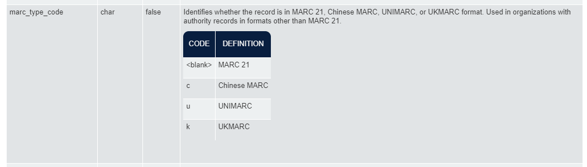
When you see presentations like this, the codes are not found in a database table.

- Scroll further down the list of tables related to Bib. They’re in alphabetical order. Eventually you should see two tables, user_defined_bcode1_myuser and user_defined_bcode2_myuser.
The so-called “user” in the table name refers to the Sierra customer, which in our case means Watson Library! Here are the descriptions as provided in the documentation.
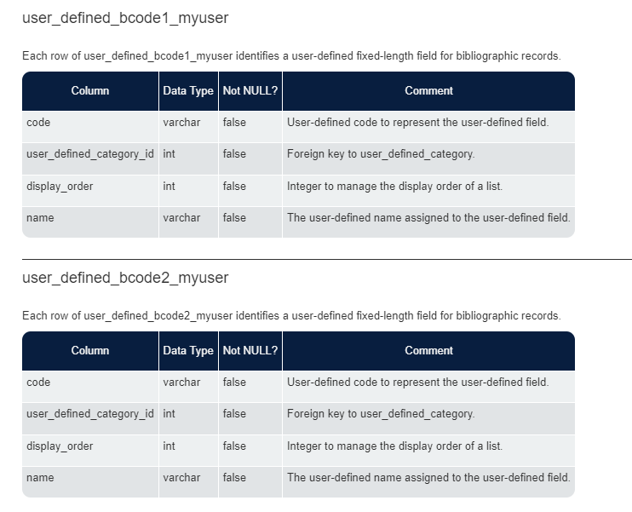
There are really only two fields we are concerned about -- the field that has the code value and the field that spells out the full code description.
It appears that in each table “name” field contains the description. Also, the “code” fields are the ones used to represent the field.
These codes are defined by the library to use as fields describing bib records. The documentation doesn’t tell us how Watson uses the fields. However, we have some sample data from our query that gives us some clues.
Let’s continue with our research...

Review what we know so far based on the sierraDNA documentation about Bibs:

bib_view field | Characteristic | Defined in
language_code | standard MARC 21 language  e.g., ‘ger’ | ??
country_code | standard MARC 21 country  e.g., ‘gw’ | ??
bcode1 | library defined code  e.g., ‘m’ | The table user_defined_bcode1_myuser  where  the “code” field repeats the code on bcode1  the “name” field has the meaning / description
bcode2 | library defined code  e.g., ‘a’ | The table user_defined_bcode2_myuser  where  the “code” field repeats the code on bcode2  the “name” field has the meaning /description

Although we might assume there is a table for countries and languages, we’re still not sure about where to get descriptions for the language_code and country_code based on what we found so far.
- Scroll down to the bottom of the Bib detail to find a link to “ERD view.”
- Click the ERD View link.
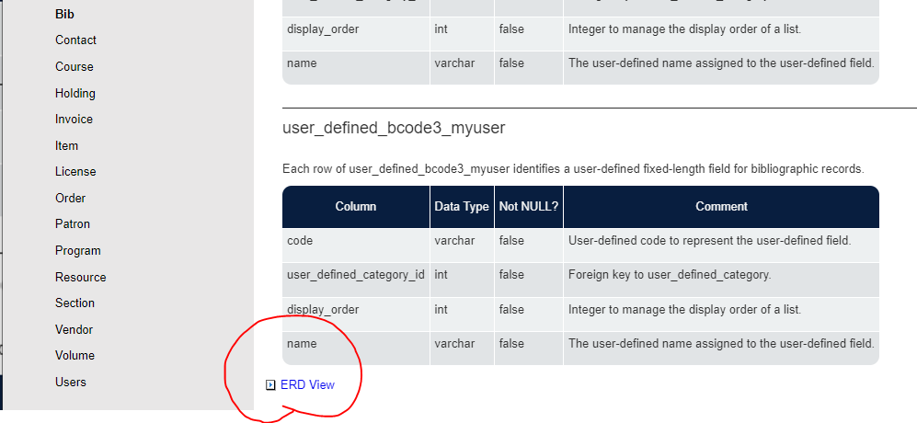

- The ERD View provides a high-level diagram showing the related tables.
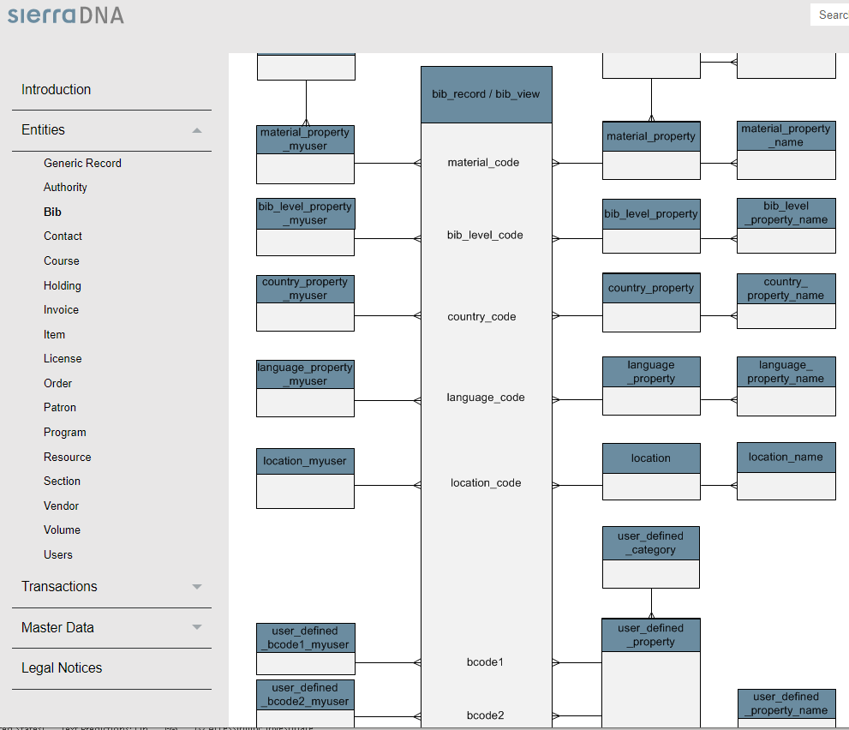

COUNTRY CODE
Following the lines leading off the bib_view table country_code field we learn that
this diagram tells us that the details about the country_code may be found in the table named “country_property_myuser”

LANGUAGE CODE
Similarly, the lines leading off the bib_view table language_code field,
we find it tells us that the details may be found in the tables named “language_property_myuser”

Let’s update what we know so far about the situation.
We found four fields on the bib_view table store codes. The sierraDNA documentation tells us characteristics about the fields and the diagram illustrates field to table relationship(s).
bib_view field | Characteristic | Related table and comment
language_code | standard MARC 21 language  e.g., ‘ger’ | language_property_myuser  the “code” field on this table matches the code on bib_view.language_code  the “name” field has the meaning / description
country_code | standard MARC 21 country  e.g., ‘gw’ | country_property_myuser  the “code” field on this table matches the code on bib_view.country_code  the “name” field has the meaning / description
bcode1 | library defined code  e.g., ‘m’ | The table user_defined_bcode1_myuser  the “code” field matches the code on bcode1  the “name” field has the meaning / description
bcode2 | library defined code  e.g., ‘a’ | The user_defined_bcode2_myuser  the “code” field matches the code on bcode2  the “name” field has the meaning /description

Alright, now we know the connection between the bib_view table and four other tables.

MAKE A DIAGRAM
It helps to make your own diagram of the related tables, including relevant fields, and to include sample data in the diagram. You might want to create a sketch for yourself.
As an example, on the next page we made a variation of the ERD View where we added some of the field names in each table and sample data from a known record we got from our original query.
On the left is the bib_view table, several fields and their values are listed.
On the right we have the four tables we determined are related, and their values.
The ‘>>’ symbols in the middle of the diagram show exactly which fields on the bib_view are related to particular fields on the related tables.
In this case all the bib_view code fields match up with a field named “code” on the related table. In addition, all of the fields that provide the descriptive text about the codes are named “name.”
Related tables
bib_view |  |  | language_property_myuser
language_code: | ger | >> | code: | ger
 |  |  | name: | German
record_type_code: | b
 |  |  | country_property_myuser
country_code: | gw | >> | code: | gw
 |  |  | name: | Germany
record_num: | 1142992
 |  |  | user_defined_bcode1_myuser
bcode1: | m | >> | code: | m
 |  |  | name: | MONOGRAPH
cataloging_date_gmt: | 1992-06-22 00:00:00-04
 |  |  | user_defined_bcode2_myuser
bcode2: | a | >> | code: | a
 |  |  | name: | Text

If you are familiar with cataloging:
- the value ‘MONOGRAPH’ (code ‘m’) should be recognizable as the bibliographic level
- and the value ‘Text’ (code ‘a’) should be recognizable as the material type.

You don’t necessarily need to make a detailed diagram for yourself. It is a good idea, however, to have a sample record in mind. That way you can verify you are looking at the correct information.

Many tables in Sierra have the same sort of code fields, whether it is the patron information, orders, vendors, etcetera. You can follow the same process that was just described to research fields and table relationships for any situation.

Now that we know the related fields and tables, we are ready to write SQL queries that bring all the pieces together. Next, we will gradually build up a complete, five table query.

Joining tables

First, let’s write a SQL query to retrieve the full name of the country for the sample record with
record_num = 1142992.

Below, we select the fields “record_num” and “name” FROM two tables, “bib_view” and “country_property_myuser”. The criteria in the WHERE statement identifies the
bib record number. In addition the WHERE clause needs to tell the system how to match the tables based on the values in the “code” fields being equal.
CREATE THE QUERY JOINING TWO TABLES

SELECT
record_num,
name
FROM
sierra_view.bib_view,
sierra_view.country_property_myuser
WHERE
record_num=1142992
AND sierra_view.bib_view.country_code = sierra_view.country_property_myuser.code

The last line of the query joins the tables on the fields that we determined they have in common.

EXPAND THE QUERY TO INCLUDE LANGUAGE (THREE TABLES)
You may expand on what we’ve developed so far by bringing in the second related table. You can do that by including the table name in the FROM clause and another line in the WHERE statement that tells the system how to join the new table.
Since the terms ‘code’ and ‘name’ are used in all these tables, you have to help the system out by removing any ambiguity. Remove ambiguity simply by adding the table name as the prefix every time the field names are mentioned in the query.
Another thing you ought to do is assign meaningful aliases to the fields instead of the vague label ‘name.’ As a reminder, you use the syntax fieldname AS alias, as shown below to create an alias.
Here is the previous query expanded to include the language. The fields are given appropriate aliases in the SELECT statement. Revised or additional lines have been highlighted.

SELECT
record_num,
sierra_view.country_property_myuser.name as country,
sierra_view.language_property_myuser.name as language
FROM
sierra_view.bib_view,
sierra_view.country_property_myuser,
sierra_view.language_property_myuser
WHERE
record_num=1142992
AND sierra_view.bib_view.country_code = sierra_view.country_property_myuser.code
AND sierra_view.bib_view.language_code = sierra_view.language_property_myuser.code

EXPAND THE QUERY TO INCLUDE BCODE1 (FOUR TABLES)
Continuing with our same example, we add another table. Here is the previous query expanded to include the bcode1 (bib level). The fields are given appropriate aliases in the SELECT statement. Revised or additional lines have been highlighted.

SELECT
record_num,
sierra_view.country_property_myuser.name as country,
sierra_view.language_property_myuser.name as language,
sierra_view.user_defined_bcode1_myuser.name as biblevel
FROM
sierra_view.bib_view,
sierra_view.country_property_myuser,
sierra_view.language_property_myuser,
sierra_view.user_defined_bcode1_myuser
WHERE
record_num=1142992
AND sierra_view.bib_view.country_code = sierra_view.country_property_myuser.code
AND sierra_view.bib_view.language_code = sierra_view.language_property_myuser.code
AND sierra_view.bib_view.bcode1 = sierra_view.user_defined_bcode1_myuser.code

EXPAND THE QUERY TO INCLUDE BCODE2 (FIVE TABLES)
Here we add the fifth table to our query. Revised or additional lines have been highlighted.

SELECT
record_num,
sierra_view.country_property_myuser.name as country,
sierra_view.language_property_myuser.name as language,
sierra_view.user_defined_bcode1_myuser.name as biblevel,
sierra_view.user_defined_bcode2_myuser.name as mattype,
FROM
sierra_view.bib_view,sierra_view.country_property_myuser,sierra_view.language_property_myuser,
sierra_view.user_defined_bcode1_myuser,
sierra_view.user_defined_bcode2_myuser
WHERE
record_num=1142992
AND sierra_view.bib_view.country_code = sierra_view.country_property_myuser.code
AND sierra_view.bib_view.language_code = sierra_view.language_property_myuser.code
AND sierra_view.bib_view.bcode1 = sierra_view.user_defined_bcode1_myuser.code
AND sierra_view.bib_view.bcode2 = sierra_view.user_defined_bcode2_myuser.code

MODIFY THE QUERY TO INCLUDE ALIASES FOR FIELDS AND TABLES (OPTIONAL)
Some programmers prefer to shorten the verbose field names by assigning aliases to the table names. Here is a revised script in which all tables are assigned a single letter alias in the FROM clause. Then each field is referenced by the table alias.

-- fields and tables with alias version
SELECT record_num,
l.name as language,
v.name as biblevel,
m.name as mattype,
c.name as pub_place
FROM
sierra_view.bib_view b,
sierra_view.language_property_myuser l ,
sierra_view.user_defined_bcode1_myuser v,
sierra_view.user_defined_bcode2_myuser m ,
sierra_view.country_property_myuser c
WHERE
record_num=1142992 AND
b.language_code = l.code AND
b.bcode1 = v.code AND
b.bcode2 = m.code AND
b.country_code = c.code

The alias may be more than one character if you prefer.
This approach of using table and field aliases is optional. If you find it confusing, use the table name prefix method in the query on the previous page.
The query output from our five table query provides the labels we chose (instead of language_code, bcode1, bcode2, and country_code) and the full text for each record rather than ‘ger’,’m’,’a’, and ‘gw’.
This is the query output:
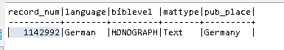
The descriptive text improves readability of the outut. Retrieving descriptive text, either in addition to or instead of code values, is a very typical use of joining tables.

Rules for joining tables
We saw that we matched the bib_view and related tables based on a common value between fields on the bib_view table and fields on the related tables. In general, the following rules apply when joining tables in SQL:
- The value in the field of one table must match the value in the field of the other table. This commonality links the tables.

- The data type in the columns on both tables must be the same. Examples of data type are integer, date, and character. If the data type is character, both fields must be the same length.

- You do not need to include the common field(s) that you use to join the tables in the SELECT statement of your query.

- The name of the column from one table can be different from the name of the matching column on the other table.
- If the name of a field on both tables is the same, it is important to prefix the field name with the table name or table alias to avoid ambiguity.

Joining tables with a WHERE clause
As we have seen, you may join tables by including criteria statements in a WHERE clause that specify which fields to match.

Let’s try a different example, this time relating to patrons.
NEW SCENARIO
You can look up patron p102999a, and you would find they have a Patron Type of 20. The question is, what does the code 20 mean? How do you output the descriptive text in addition to, or in place of the code?
You can approach this question using the same steps we followed in the previous example with Bib related fields and tables.

- IDENTIFY THE RELATED TABLES AND THEIR COMMON FIELDS
You can use sierraDNA to view the fields on any table. There you will see that the patron_view table and ptype_property_myuser table have a certain field in common.
- go to the sierraDNA site
- click Entities
- click Patron
- click Detailed View
- scroll down to patron_view
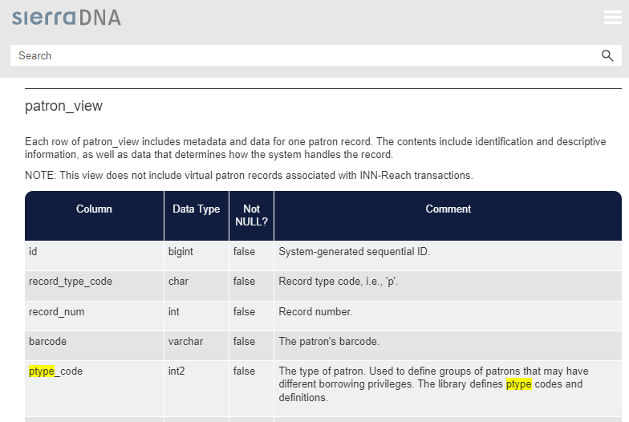

The list of fields on patron_view includes a field named “ptype_code” which the comment indicates is
the type of patron.

Next find where ptype_codes are defined.
- scroll down the list of other patron related tables
- find ptype_property_myuser
- notice the field named “value” has a comment that says it is the patron type code
- the field named “name” contains the patron type name/description
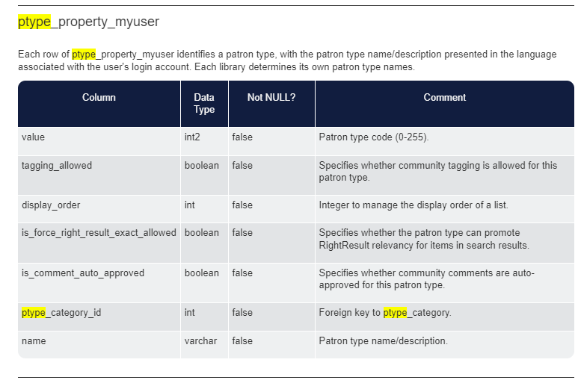

- ADD THE FIELD YOU WANT IN THE SELECT STATEMENT AND BOTH TABLE NAMES
TO THE QUERY’S FROM CLAUSE
When you are joining tables using a WHERE clause, you must include both table names in the FROM
clause so the query knows where/how it will JOIN the tables.
SELECT
record_num, ptype_code, name
FROM
sierra_view.patron_view, sierra_view.ptype_property_myuser

- ASSIGN TABLE ALIASES
Optionally, give the tables short alias names to make referring to them easier.
FROM
sierra_view.patron_view P, sierra_view.ptype_property_myuser N
- JOIN THE TABLES ON THEIR COMMON FIELD

WHERE
P.ptype_code = N.value

Here is a complete script that retrieves the name that corresponds to the patron type code.
The query joins the ptype_property_myuser lookup table and the patron_view table.

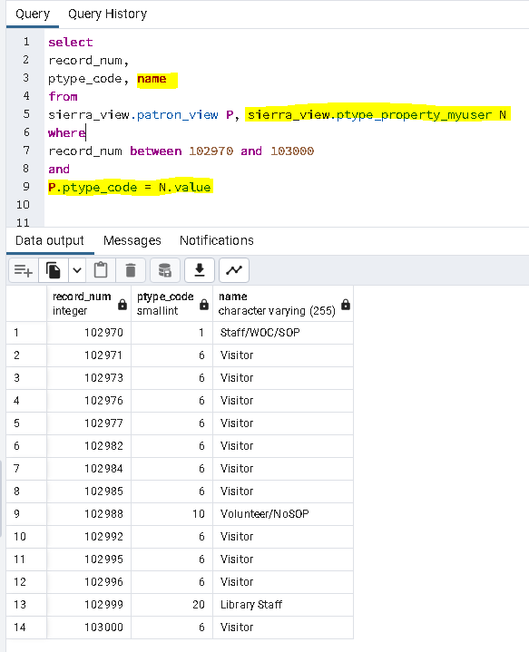
The following statements mean the same thing. The latter takes advantage of the table alias:
- sierra_view.patron_view.ptype_code = sierra_view.ptype_property_myuser.value
- P.ptype_code = N.value
Optionally, edit the query by assigning an alias for the field “name” such as “patron_type.”

Joining tables with the JOIN statement

The second technique for combining tables is to use a “join” statement INSTEAD OF THE WHERE CLAUSE. Here is the syntax pattern.
SELECT field1, field2 ... fieldN FROM table1
JOIN table2 on table1.fieldname = table2.fieldname
When using this technique, you do not list both tables in the FROM clause.
You can assign an alias and use the alias in the JOIN statement.
Here is a revision of our patron_type query using the JOIN statement syntax.
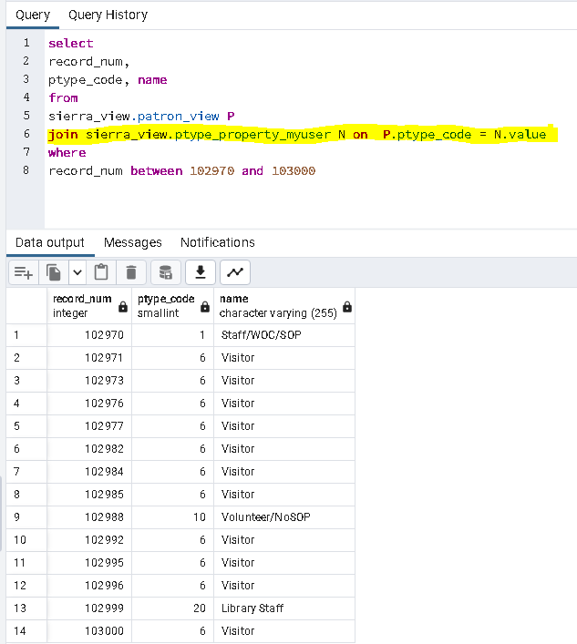
The results are the same whether you use a WHERE clause or JOIN statement.
Using the JOIN syntax is the preferred method.

Examples

Here are more examples of joining pairs of tables.
Exampe 1a: using JOIN statement
Watson uses the field pcode1 on the patron_view table to identify the Institution.
SELECT
record_num, barcode, pcode1, name as Institution
FROM
sierra_view.patron_view P
JOIN sierra_view.user_defined_pcode1_myuser C on P.pcode1 = C.code
WHERE
C.name like '%Museum%' and barcode like '2062%14'

Example 1b: using WHERE clause

SELECT
record_num, barcode, pcode1, name as Institution
FROM
sierra_view.patron_view P,sierra_view.user_defined_pcode1_myuser C
WHERE
P.pcode1 = C.code
and
C.name like '%Museum%' and barcode like '2062%14'

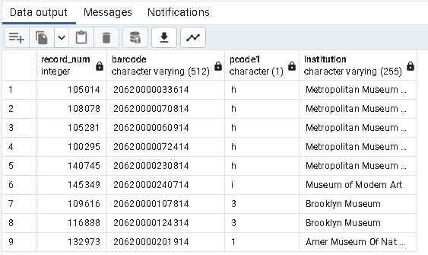
After considering this output, you might consider enhancing the query by replacing pcode1 with the descriptive text.

Example 2 using JOIN statement
Watson uses the field pcode3 on the patron_view table to identify Departments in the Museum.

SELECT
record_num,
barcode,
pcode3,
name as Department
FROM
sierra_view.patron_view P
JOIN sierra_view.user_defined_pcode3_myuser C on P.pcode3 =
cast((C.code) as int)
WHERE
barcode not like '2062%'and pcode3 != 1 and barcode like '%321'

This is rare, but the joined fields are different data types. One is an integer and the other is a character. The statement “cast((C.code) as int)” means treat the code as an integer.

Query output showing the department description that corresponds to pcode3:

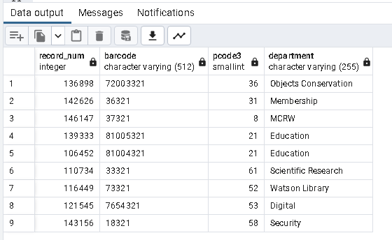

Joining Data Tables

We saw that many tables provide descriptive text for codes. The purpose of those tables is not to store information about a particular thing, like a bib, item, hold, order, etc. Other tables store that data, and so we will refer to them as “data tables.” Data tables often have a lot of fields and the information from several data tables can be combined to get a complete picture of, let’s say a patron. Joining these data tables typically involves using the record number or a system generated id number.

bib_view and varfield_view

The table varfield_view stores the MARC tags, indicators, and subfields related to bib records. Each row in the table represents a tag, and the value is stored in a field named “field_content.” Here is an example of a two-table join.
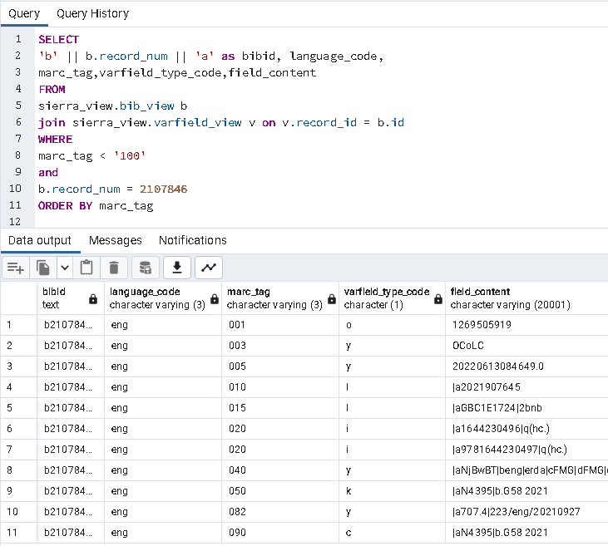
It is normal for some values in the field_content to contain the subfield delimiters (|a, |b, |c, etc.) as shown in the query output above.

bib_view, item_view, and bib_record_item_record_link

If we want to list all the items associated with a bib record one problem is that the item record does not contain the bib id number. The bib record itself does not have a list of associated items.
The database has a table that serves to link the bib and item tables. That table is named
“bib_record_item_record_link.”
You might picture the relationship between these three tables as illustrated in the diagram below. The diagram is similar to what you will find in sierraDNA ERD View. We added sample values for some fields which makes it a little more understandable.
The linking table is in the middle. The “item_record_id” field on the linking table matches the “id” field on the item_view (at left; note the content of the fields are the same, but the field names are different), and the “bib_record_id” on the linking table matches the “id” field on the bib_view (at right; again, the content of the fields match, but the field names are different).

item_view | bib_record_item_record_link | bib_view
id: 1221474 < - - - - - - - - - - | item_record_id: 1221474
item_loc: s  barcode: 30620001142719 | bib_record_id: 1115022 - - - - - - - - - - > | id: 1115022  Title: Art in America
Relationship diagram

NOTE: If there aren’t any items linked to a bib record, there will not be a bib_record_item_record_link.

The following query demonstrates three table joins, and outputs fields from item_view and bib_view. It identifies bibs with items.

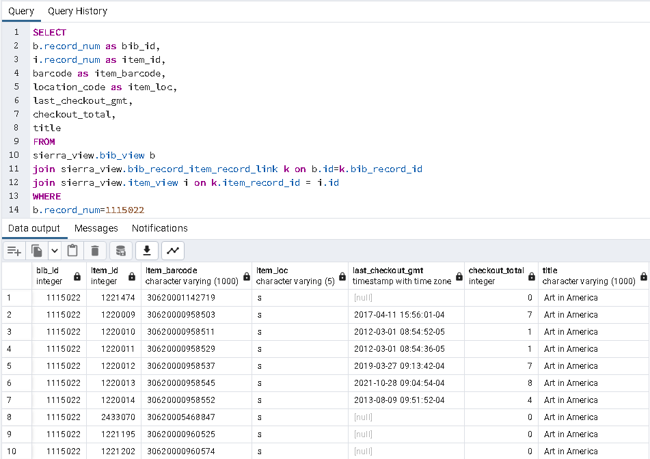

A specific bib record was used for the query. That bib record is linked to ten items.

hold, patron_record_fullname, item_view, and bib_record_item_record_link

We looked at a query for holds in Part One, Exercise 10. This is the output from that Exercise:
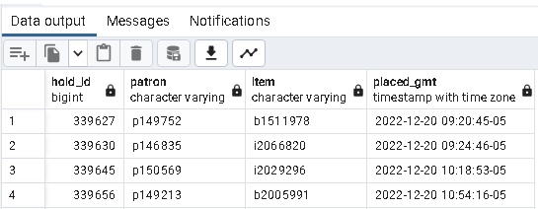

The hold query may be enhanced by retrieving the item barcode, patron name and bib_id from other tables. A four-table join is needed. Here is the revised query and output.
SELECT
barcode,h.id AS hold_id,id2reckey(h.record_id) AS item_id,
placed_gmt AS request_datetime,id2reckey(h.patron_record_id) AS patron_id,
last_name || ', ' || left(first_name,1) AS patronname,
id2reckey(k.bib_record_id) AS bib_id
FROM
sierra_view.hold h
JOIN sierra_view.patron_record_fullname f on
h.patron_record_id = f.patron_record_id
JOIN sierra_view.item_view i on h.record_id = i.id
JOIN sierra_view.bib_record_item_record_link k on i.id = k.item_record_id
WHERE i.location_code = 'off' and placed_gmt > '2022-12-22'
ORDER BY hold_id

Off-site holds. Detail query using JOIN statements to connect four tables

Revised data output:
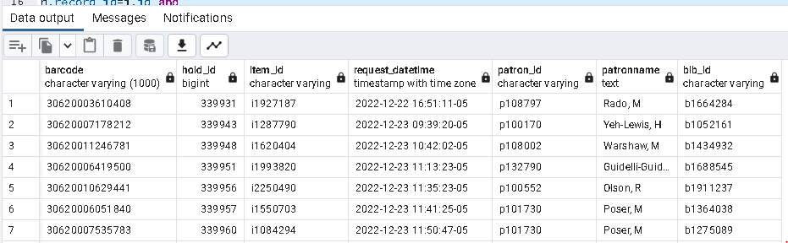

Tables often used in queries

At this point you’ve been introduced to several tables and the type of data they contain. You know how to use pgAdmin to explore the contents of the tables. Here is a reminder of some of the more useful tables.
bib_view | item_view
varfield_view | phrase_entry
bib_record_location | location
bib_record_property | patron_record_fullname
bib_record_item_record_link | user_defined_<x>_myuser
patron_view | hold

Left Joins

There are scenarios when using the standard Join statement results in excluding some data.
Let’s look at an example when you need a different join statement, a “left join” statement.
First we will look at how to get the standard join figured out in the first place.
Below you see a simple query that retrieves three fields from one table, the item_view table.

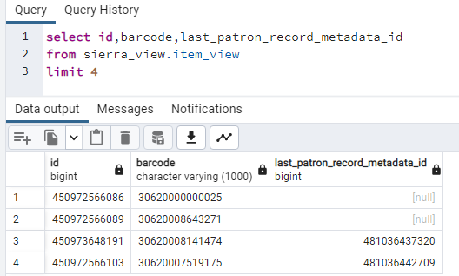

The data output provides an id of the last patron who checked out each item.
In the first two rows, the value of “last_patron_record_metadata_id” is [null] indicating those items were never checked out.
The last two items in the data output display a “last_patron_record_metadata_id” value.
Let’s suppose we want to retrieve the names of patrons who last checked out the items.

STEPS TO FINDING THE PATRON’S NAME
If you look at the item_view information in sierraDNA, it tells you the table record_metadata connects to the system generated id, “last_patron_record_metadata_id.”

- The item_view description in sierraDNA says the last_patron_record_metadata_id is a “Foreign key to record_metadata (for the last patron record).”
- The record_metadata table stores ids of bibs, items, patrons etc. By the name of the field “last_patron_record_metatdata_id” we can be confident that the value 481036437320 is a patron’s system generated id.
- If you use sierraDNA to browse the patron tables, you discover the patron’s name is included in a table named patron_record_fullname.
- You could run a quick SQL query in pgAdmin for patron_record_fullname with an id from the preceding example, 481036437320:
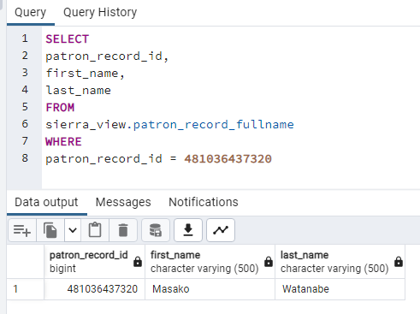

We know the last_patron_record_metadata_id is a patron id, so we should be able to matchup the tables based on that id. A diagram to illustrate the relationship between the tables may help.
You might sketch the relationship with sample data like this:

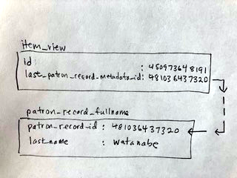

Now we know our standard join statement, not including table aliases. It should say:

...
FROM
sierra_view.item_view
join sierra_view.patron_record_fullname on
sierra_view.item_view.last_patron_record_metadata_id =
sierra_view.patron_record_fullname.patron_record_id

Here then is a query that uses a standard join between these two tables on their matching fields. The query assigns the tables aliases (‘i’ and ‘f’) for convenience. In the SELECT clause, the field named ‘id’ is given the table prefix ‘i.’ to avoid ambiguity.

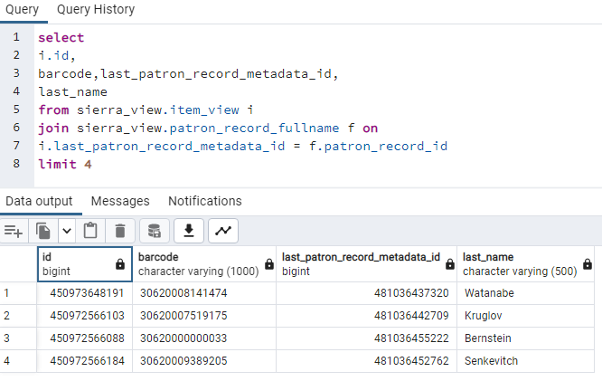

Analyze the result
The barcodes in rows 1 and 2 of this result are the same ones in rows 3 and 4 of the original query output (30620008141474 and 30620007519175). The query returned the patron name for rows Watanabe and Kruglov.
The problem is that in the original query’s output the barcodes in rows 1 and 2 are now missing from the output of the joined table query (30620000000025 and 30620008643271).
Instead, the system returned two other rows that it found which have items with a previous checkout.
The item_view table had [null] values for last_patron_record_metadata_ids. There wasn’t any patron record to match. Therefore, the first two lines got dropped from the results!

Assume we intended to get all the items from item_view. Also, we want to retrieve the names of the last patrons to checkout the item AND if there is no checkout, then we want to keep the item_view record anyway.
Solution: left join
In this example you might literally picture the item_view table (the one you want all records from) as being on the left side of the equal sign in an equation. Whereas the patron_record_fullname table, which may or may not be matched, is on the right of the equal sign of a WHERE statement:
The SQL term we use to indicate we want all records on the left is “LEFT JOIN.”

left join syntax

As a reminder, we use a “join” statement INSTEAD OF THE WHERE CLAUSE. Here is the syntax pattern again, this time with the term “LEFT” preceding the term JOIN.

SELECT field1, field2 ... fieldN FROM table1
LEFT JOIN table2 on table1.fieldname = table2.fieldname

When using this technique, you do not list both tables in the FROM clause.
You can assign an alias and use the alias in the JOIN statement.

Here is the revised query using left join (line 6 and 7) instead of the standard join:

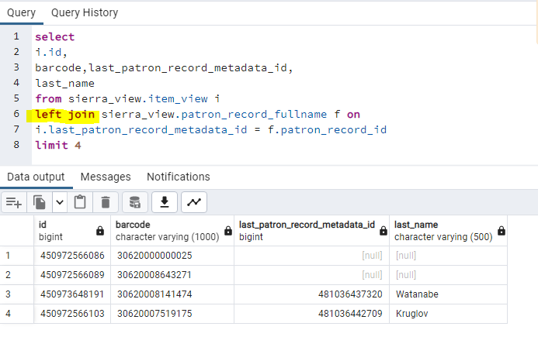

Success! Now we have all four of the original rows from the item_view table. The first two rows in the output show the last_patron_record_metadata_id and last_name values as [null], which is correct.
The original rows 1 & 2 were not dropped from the output.
Lines 3 and 4 include the last name of the patron which checked out the item.

Left join examples

Patrons and patron_addresses

Here is an example of using a LEFT JOIN between patrons and patron_addresses.

SELECT 'p' || record_num || 'a' as patronid,addr1
FROM
sierra_view.patron_view p
LEFT JOIN sierra_view.patron_record_address a
ON p.id = a.patron_record_id
WHERE
ptype_code = 6
LIMIT 10

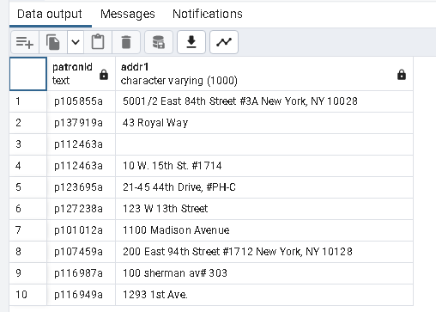

Notes: The patron on line 3 does not have an address, but because the ‘left join’ statement is used the record was not excluded from the output.

Patrons on line 1 and 8 have the city, state, and zip code all in the addr1 field. This should be corrected. There are separate fields for city, state, and zip code.

Bibs and items

Here is another typical example of using a LEFT JOIN connecting bib_view, bib_record_item_record_link and item_view.
SELECT
b.record_num as bibid,title,i.record_num as itemid, barcode
FROM
sierra_view.bib_view b
LEFT JOIN sierra_view.bib_record_item_record_link k
ON b.id = k.bib_record_id
LEFT JOIN sierra_view.item_view i
ON i.id = k.item_record_id
WHERE
title like 'Burea%and%'

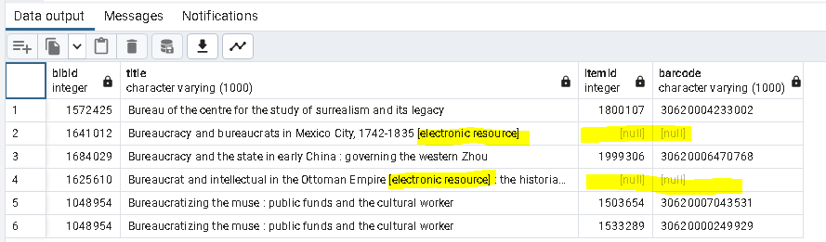

Notes: The bib records on lines 2 and 4 do not have items attached, but because the ‘left join’ statement is used the records were not excluded from the output.

If you do not include a left join between item_view and bib_record_item_view link lines 2 and 4 would be excluded from the output.

Electronic Resources do not normally have an item with a barcode, so this is correct.

Bib id 1048954 on lines 5 and 6 is listed twice, one row for each item.

Further Study

You have completed a basic, introductory level course on SQL queries with the Sierra database using pgAdmin.
Here is a list of several resources you can use if you find you require something more sophisticated than a basic query.
- See the Appendix of this document for a few examples of slightly more complex SQL queries we use in Watson.
- If you have access to the Systems folders on the shared drive, you can find examples of complex SQL queries in the course materials from the Innovative SQL Workshop and from IUG Conferences.
  - SY_Systems > SY_Hardware and Software > Innovative > Sierra > SierraDNA SQL
    - Adv_SQL_Workshop_Queries.txt
    - Sierra_SQL_Workshop_2.pdf
    - SierraAdvancedSQLcourse.docx
    - IUG 2017 – Sierra Direct SQL Access – Davidson and Matta.pptx
    - IUG 2021 – SQL – Jeremy Goldstein.pptx
    - WILIUG_Sierra_Direct_SQL_Access_101_PPT_061214.pdf
- If you are able to attend a follow up “SQL Jam” hands-on workshop, you will be able to try some multi-table join exercises.

Appendix

Some SQL Queries used at Watson Library

Address checker

SELECT DISTINCT
v.id as system_id,
checkout_total,
'out',
checkout_count,
to_char(activity_gmt, 'YYYY') as recency,
-- searchable id, where a is a wildcard replacing the check digit
'.p' || v.record_num || 'a' as patron_rec_id,
UPPER(first_name) as first_name,
UPPER(last_name) as last_name,
CASE
WHEN (addr2 ISNULL AND city ISNULL AND region ISNULL and
postal_code ISNULL)
THEN 'ADDRESS NEEDS UPDATE'
WHEN (LENGTH(addr2) > 2 AND LENGTH(city)=2) THEN UPPER(addr2)
WHEN (city = 'NY') THEN 'NEW YORK'
WHEN (city ISNULL) THEN 'ADDRESS NEEDS CITY'
ELSE
UPPER(city)
END as city,
CASE
WHEN region > '' THEN regexp_replace(region, '\.', '', 'g')
WHEN (LENGTH(city)=2 AND addr2 >'') THEN UPPER(city)
WHEN city = 'New York' THEN 'NY'
ELSE
UPPER(region)
END AS region,
CASE
WHEN (country ISNULL) THEN 'United States'
ELSE
country
END AS country,
postal_code,
-- calculate the status
CASE
WHEN expiration_date_gmt isnull THEN 'ACTIVE'
WHEN expiration_date_gmt > NOW() THEN 'ACTIVE'
ELSE
'EXPIRED'
END as status
FROM
sierra_view.patron_view v
JOIN sierra_view.patron_record_fullname n
ON v.id = n.patron_record_id
JOIN sierra_view.user_defined_pcode1_myuser q
ON v.pcode1 = q.code
JOIN sierra_view.user_defined_pcode2_myuser r
ON v.pcode2 = r.code
JOIN sierra_view.record_metadata m
ON v.id = m.id
-- some records, might not have a patron address
LEFT JOIN sierra_view.patron_record_address a
ON v.id = a.patron_record_id
WHERE
v.ptype_code in ('6')
AND m.record_type_code='p'
ORDER BY recency
limit 30000

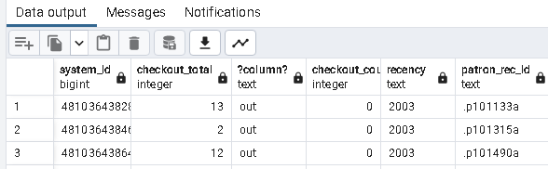 …
…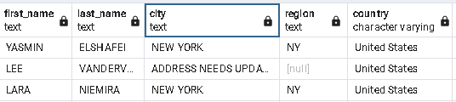…
…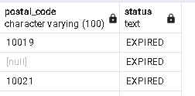

Items checked out from book cage

SELECT
i.record_num as item_record_num,
i.barcode as item_barcode,
i.record_creation_date_gmt as item_created,
b.record_num as b_record_num,
b.country_code,
b.language_code,
b.title,
checkout_gmt,
p.record_num as patron_record_num,
p.id as patron_metadata_id,
i.last_checkout_gmt,
i.last_patron_record_metadata_id
FROM
sierra_view.checkout c,
sierra_view.patron_view p,
sierra_view.item_view i,
sierra_view.bib_view b,
sierra_view.bib_record_item_record_link k
WHERE
c.item_record_id=i.id
and
c.patron_record_id=p.id
and
i.id=k.item_record_id
and
b.id=k.bib_record_id
and
i.location_code='bc'
and
checkout_gmt > '2022-12-20'

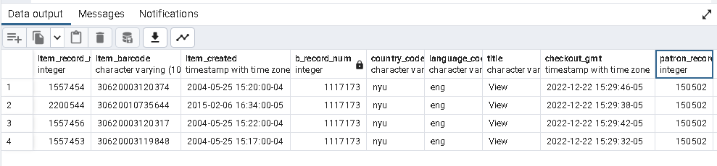

All patrons
SELECT
v.field_content as barcode,
v.record_num as recno,
CASE
WHEN COALESCE(to_char(expiration_date_gmt, 'YYYY-MM-DD'), '')
> '2022-11-04'
THEN 'A'
WHEN COALESCE(to_char(expiration_date_gmt, 'YYYY-MM-DD'), '')
= ''
THEN 'A'
ELSE 'XX'
END as stat,
CASE
WHEN ptype_code = 6
THEN 'VR'
ELSE 'S'
END as ptype,
pcode1 as aff,
pcode2 as grp,
pcode3 as dept
FROM
sierra_view.patron_view p,
sierra_view.varfield_view v
WHERE
p.record_num = v.record_num
and v.record_type_code= 'p'
and v.varfield_type_code ='b'

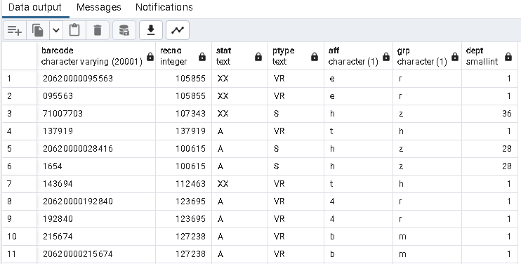

Cover generated by https://orly.nanmu.me/
There are situations where a so-called “LEFT JOIN” statement is required. This will be explained later.

